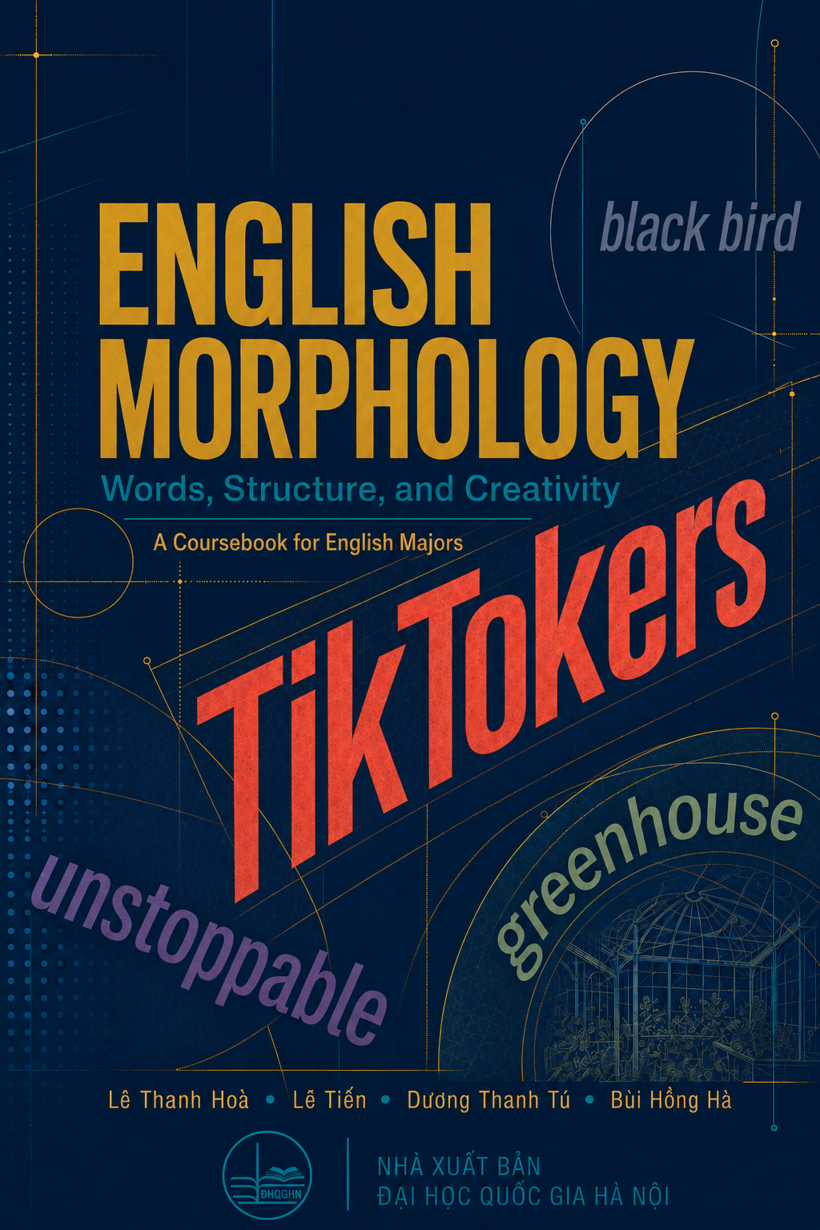

ENGLISH MORPHOLOGY
Words, Structure, and Creativity
A Coursebook for English Majors

Lê Thanh Hoà • Lê Tiến • Dương Thanh Tú • Bùi Hồng Hà

VNU PRESS
NHÀ XUẤT BẢN ĐẠI HỌC QUỐC GIA HÀ NỘI

PREFACE
A Coursebook for English Majors
English Morphology: Words, Structure, and Creativity is intended for upper-intermediate undergraduate students in English Language Studies and English Language Teacher Education.
Instead of beginning with abstract definitions, each unit introduces morphology through a familiar word or expression, such as TikTokers, YouTubers, unstoppable, blackbird, vlog, emoji, or DM me. Students are guided to notice patterns, propose explanations, examine evidence, test their analyses, and refine their conclusions. Through this process, key concepts - including morpheme, root, base, stem, derivation, inflection, compounding, productivity, and allomorphy - are developed through guided discovery as well as systematic explanation.
The coursebook seeks to combine accessibility with academic rigour. It draws attention to the relationships among form, meaning, and grammatical function while encouraging students to explore authentic language through real-life examples, dictionaries, and corpus data.
We hope that the coursebook will help students understand the structure and creativity of English words and become thoughtful observers of language: learners who ask meaningful questions, reason from evidence, and use language with confidence. Every word has a structural story - and the next word may begin with the learner.
The Authors
Dong Nai, July 2026

CONTENTS
UNIT | TITLE · GUIDING QUESTION | PAGE
1 | TIKTOKERS  TikTok is a platform. Who are TikTokers? | 6
2 | RESEARCHER  Where would you split this word? | 15
3 | DREAMERS  What part do these words share? | 22
4 | CATS · DOGS · FOXES  They all end in “s”. Why don’t they sound the same? | 30
5 | YOUTUBERS  What happened before the final “s”? | 36
6 | CREATOR  How many words can grow from “create”? | 42
7 | UNSTOPPABLE  Which two parts joined first? | 48
8 | BLACKBIRD OR BLACK BIRD?  Same bird? Same meaning? | 54
9 | VLOG  What happened to “video” and “blog”? | 60
10 | BOOKWORM  Where is the worm? | 66
11 | FACEBOOKER?  You understand it - but would you use it? | 72
12 | SCROLLING  Is “scrolling” doing the same job in every sentence? | 78
13 | EMOJI  Does it come from “emotion”? | 84
14 | DM ME  How did two letters become a verb? | 90
15 | THE NEXT WORD  Could it begin with you? | 96
 | APPENDIX A - SUGGESTED ANSWERS | 105
 | APPENDIX B - SUGGESTED THREE-HOUR TEACHING PLANS | 121
 | REFERENCES | 136

HOW TO USE THIS BOOK
Each unit begins with a familiar word or expression and a question. Students first observe language, then formulate and test analyses before formal terminology is consolidated.
NOTICE. Start from visible or audible patterns.
CONNECT. Relate changes in form to meaning and grammatical function.
EXPLAIN. Build an analysis and support it with evidence.
TEST. Use counterexamples, dictionaries, corpora, and peer interpretations.
CREATE. Transfer the pattern to new data or a new formation.
REFLECT. State what the evidence supports and what remains uncertain.
Suggested answers and teaching plans are collected at the end of the book so that the main units remain spaces for discovery.

UNIT 1
TIKTOKERS
TikTok is a platform. Who are TikTokers?
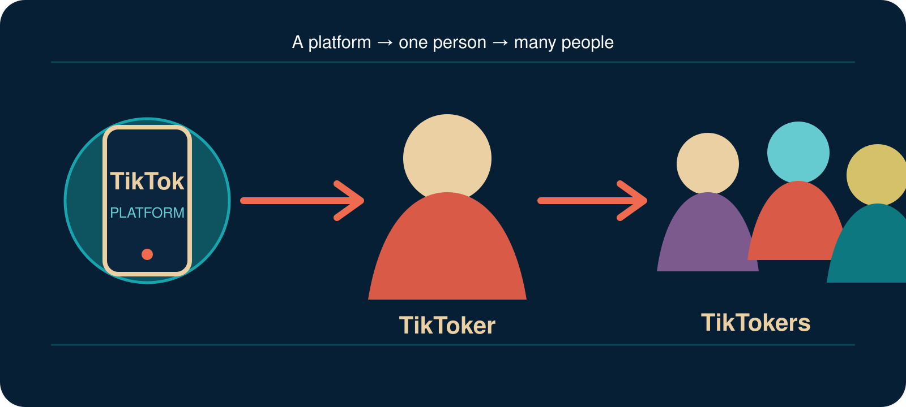
A platform can give us a new word for one person-and another form for many people. How does this happen?
LOOK CLOSELY. SMALL CHANGES CAN DO BIG JOBS.

YOUR DISCOVERY PATH
In this unit, you will:
 NOTICE small changes in word form.
 CONNECT changes in form with changes in meaning or grammatical function.
 EXPLAIN the relationship among TikTok, TikToker, and TikTokers.
 TEST whether spelling alone can explain a word’s structure.
 COLLECT real-life language data safely and responsibly.
 CREATE a new word for an online identity and test whether others understand it.

THE JOURNEY
1. NOTICE | 2. TEST | 3. EXPLAIN | 4. CREATE
Look at familiar words. | Try a pattern and challenge it. | Use form, meaning and function. | Build and test a new word.
Important: You do not need to know the terms morpheme, root, stem or allomorph yet. These ideas will come later. First, learn to notice what words do.

1. BEFORE YOU BEGIN

YOUR DIGITAL NAME
When people meet, they often exchange names. Online, they may also create usernames, display names, channel names or gaming names.
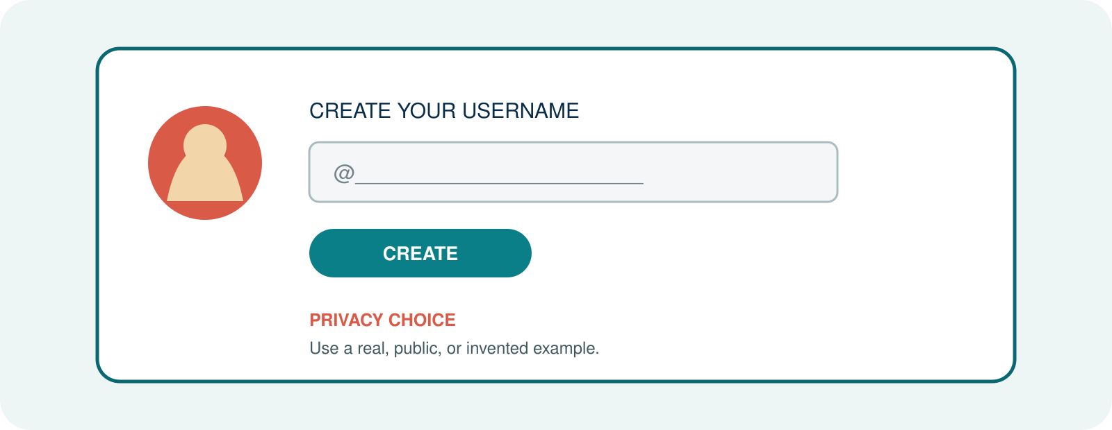
Create a username or choose a public example. You do not need to share a real personal account.
A. Write your example.

B. What does the name tell us about the person?

C. Is it made from one familiar word or several parts?

D. Would another English speaker understand it? Why or why not?

PRIVACY CHOICE: Use a real example, a public example or an invented example. Do not share private account information.

2. FIRST LOOK
Look at the three expressions. Do not use technical terms yet.
TikTok
TikToker
TikTokers
Expression | What stays? | What changes? | What does it refer to?
TikTok
TikToker
TikTokers

TALK ABOUT IT
Q1. Which expression names a platform?

Q2. Which expression refers to one person?

Q3. Which expression refers to more than one person?

Q4. Do -er and -s appear to do the same job? Explain your first idea.

3. ONE PLATFORM, DIFFERENT PEOPLE
S1. TikTok is a social-media platform.
S2. Linh is a TikToker.
S3. Many TikTokers create short videos.
S4. Those TikTokers are discussing language learning.
Complete the two statements.
A. Adding __________ helps create a word that refers to a person.

B. Adding __________ tells us that there is more than one.

A SMALL CHANGE, A DIFFERENT JOB
In TikToker, -er helps create a word for a person connected with TikTok. In TikTokers, final -s does not create a new kind of person. It gives information about number.
First working idea: Some changes help create new words. Other changes give grammatical information.
This first distinction prepares us for derivation and inflection, two central areas of morphological analysis (Lieber, 2016).

4. DOES THE PATTERN TRAVEL?
Starting form | One person | More than one
YouTube | YouTuber | YouTubers
stream | streamer | streamers
game | gamer | gamers
blog | blogger | bloggers
Q5. What form appears in all the words for one person?

Q6. What form appears in all the plural words?

Q7. What spelling change can you see in blogger?

5. BUILD A WORKING IDEA
A working idea is not a final rule. It is an explanation that we can test with more data.
H1. In these examples, -er appears to ____________________________________.

H2. The final -s appears to ____________________________________________.

CHALLENGE YOUR IDEA
Now look at these words:
teacher singer corner brother summer
Q8. Do all five words end with the letters er?

Q9. Does er have the same job in all five words?

Q10. Can corner be explained from corn in the same way that teacher can be explained from teach?

FIRST PRINCIPLE: A repeated sequence of letters is not automatically a meaningful or functional part of a word.
Carstairs-McCarthy (2002, pp. 16–17) similarly warns that recurring form and meaning must be examined carefully when morphemes are identified.

WHAT EVIDENCE CAN WE USE?
Evidence | Question
Form | Does the same form appear in related words?
Meaning | Does the part make a regular contribution to meaning?
Function | Does the part do a regular job?
Relationships | Can we connect the word with a clear family?
Use | Do real speakers use the form in this way?

6. WHICH ONE DOES NOT BELONG?
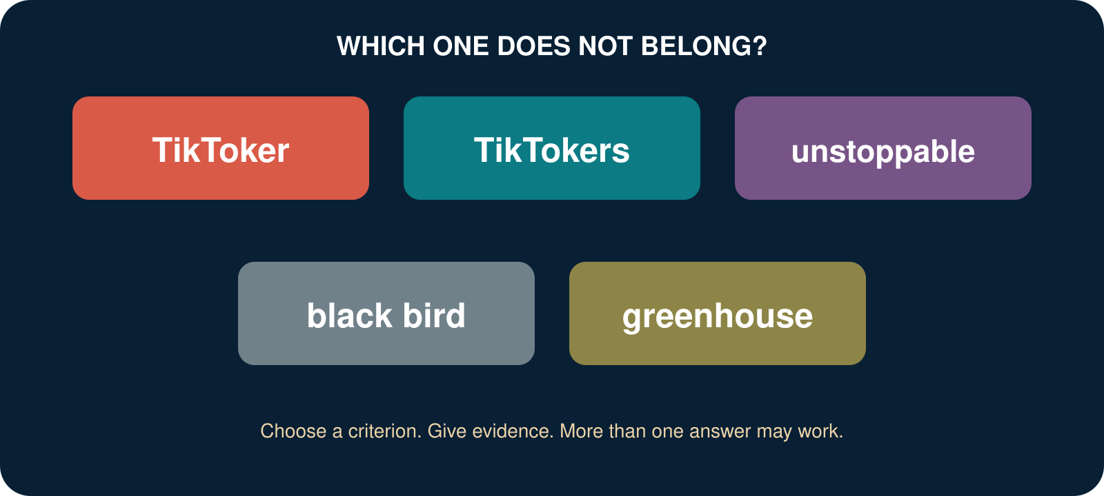
Choose one expression. Create a criterion and support it with observable evidence. More than one answer may work.
A. I think __________________ does not belong because ____________________________.

B. What evidence supports your choice?

C. Can another group choose a different expression and still give a good answer? Explain.

The goal is not to guess the teacher's answer. The goal is to build a clear criterion and defend it.

7. SO, WHAT IS MORPHOLOGY?
You have already noticed repeated forms, changes in meaning, grammatical information and relationships among words. Now we need a name for this area of study.
Morphology studies the internal structure of words, the formation of words, and systematic relationships among related word forms (Carstairs-McCarthy, 2002, p. 16; Lieber, 2016).

IN SIMPLE WORDS
INSIDE. What may a word contain?
CHANGE. How can word forms change?
CREATE. How are new words created?
MEAN. How does structure contribute to meaning?
FUNCTION. How does a form give grammatical information?

QUESTIONS FOR THIS COURSE
C1. How did TikTok become TikToker and TikTokers?
C2. Why is unstoppable more complex than stop?
C3. Is black bird one word or two?
C4. Why does greenhouse not simply mean ‘a house that is green’?
C5. Can speakers create words that are not yet in a dictionary?
Q11. Which question interests you most? Why?

8. FORM, MEANING AND FUNCTION
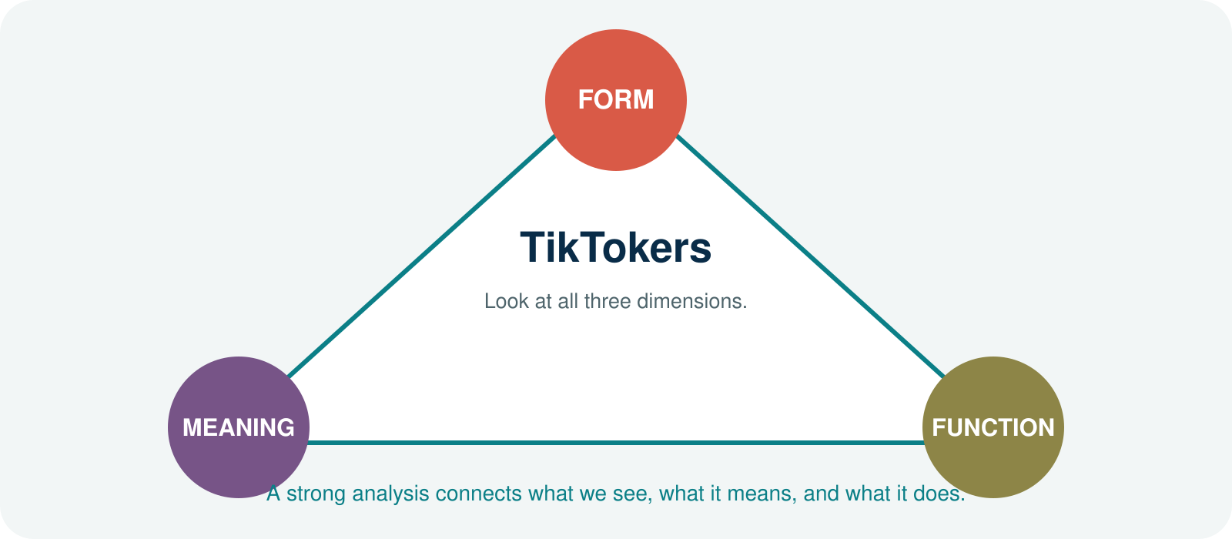
FORM. What does the expression look or sound like?
MEANING. What does the whole expression-or one of its parts-help us understand?
FUNCTION. What job does a form perform in a word or sentence?

TRY IT: YOUTUBERS
Dimension | Your observation
Form
Meaning
Function
A strong analysis connects what we see, what it means, and what it does.

9. OUR LIVING WORD COLLECTION
Language does not stop at the classroom door. During this course, the class will build a shared collection of interesting words and expressions.
Expression | Where did you notice it? | What interests you?

SAFE AND RESPONSIBLE DATA
PRIVACY. Do not include private account information.
CHOICE. You may replace a personal example with a similar invented one.
SOURCE. For a public example, record where and when you noticed it.
UNCERTAINTY. You do not need a final analysis yet. A good question is useful data.
Example: FACEBOOKER? - I understand it, but I am not sure people commonly use it.

10. WORD LAB: BUILD A DIGITAL IDENTITY
Choose a base that matters to you. You may use book, game, stream, study, design, language, coffee, travel-or another base.
A. My new formation:

B. Its intended meaning:

C. Why might another person understand it?

D. Would I actually use it? Why or why not?

PEER TEST
Do not explain your formation first. Show it to a partner and ask the partner to guess.
P1. What person or group might this word refer to?

P2. Which part helped you guess?

P3. Is the formation easy to understand?

P4. Does it sound natural to you?

P5. Are ‘easy to understand’ and ‘natural’ the same?

CREATIVITY CHECK: A new form should not only look interesting. It should give another person enough evidence to build a meaning.

11. CHECK YOUR UNDERSTANDING

A. NOTICE
A1. What changes in YouTube → YouTuber → YouTubers?

A2. What changes in stream → streamer → streamers?

B. EXPLAIN
B1. How can -er help create a word for a person in the data from this unit?

B2. What information can final -s give?

C. QUESTION
C1. Why should we not say that every word ending in the letters er has the same structure?

D. TRANSFER
D1. Choose one new formation outside this unit. What part can you identify?

D2. What meaning or function do you think that part contributes?

D3. What are you still unsure about?

12. WHAT CAN YOU DO NOW?
CAN DO 1. I can notice that words may have internal structure.
CAN DO 2. I can connect changes in form with changes in meaning or grammar.
CAN DO 3. I can give a first explanation of TikTok → TikToker → TikTokers.
CAN DO 4. I can explain why spelling alone is not enough for word analysis.
CAN DO 5. I can collect a language example safely and responsibly.
CAN DO 6. I can create an identity word and test whether another person understands it.
Not yet required: a full definition of morpheme; morph versus allomorph; root, base and stem; formal derivation–inflection criteria; morphological trees.

EXIT REFLECTION
R1. I used to think that a word...

R2. Now I notice that...

R3. One question I still have is...

13. NEXT UNIT
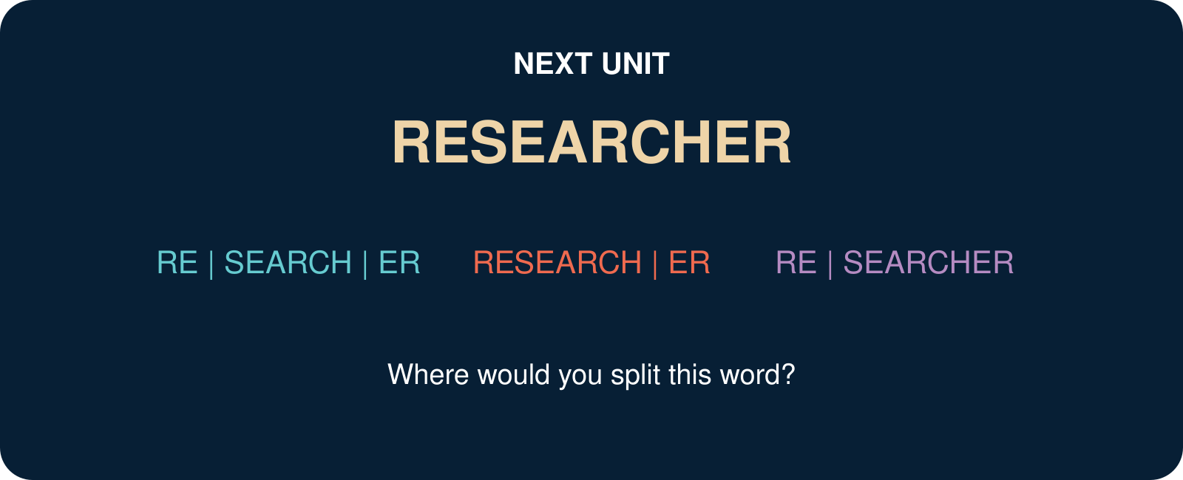
A sequence of letters may look familiar. But when does it become a real part of a word?
Bring one word that you are not sure how to split. It may become part of the next lesson.

SOURCES USED IN THIS UNIT
The explanations in this trial unit are pedagogical adaptations. The foundational definition and the caution against spelling-only analysis draw on the following academic sources:
Carstairs-McCarthy, A. (2002). An introduction to English morphology: Words and their structure. Edinburgh University Press.
Lieber, R. (2016). Introducing morphology (2nd ed.). Cambridge University Press.

UNIT 2
RESEARCHER
Where would you split this word?
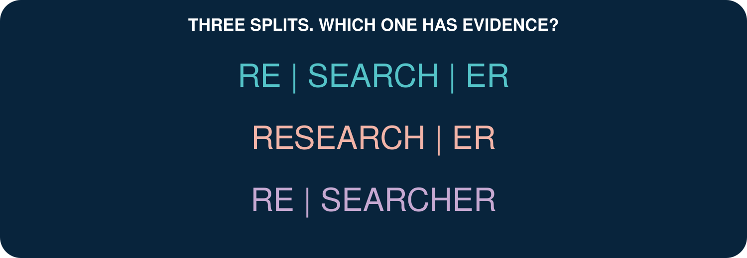
The eye can see several boundaries. Morphological analysis asks which boundary has evidence.
DO NOT JUST CUT THE WORD. BUILD A CASE.

YOUR DISCOVERY PATH
In this unit, you will:
 NOTICE recurring forms in related words.
 COMPARE possible ways of dividing researcher.
 IDENTIFY a first set of roots and affixes.
 DISTINGUISH free morphemes from bound morphemes.
 TEST a proposed morpheme with form, meaning, function, and distribution.
 CREATE a word-family map and defend your analysis.
1. NOTICE | 2. COMPARE | 3. TEST | 4. EXPLAIN
Find recurring forms. | Try more than one split. | Use several kinds of evidence. | Defend the best analysis.

1. THE WORD ON THE SCREEN
A student sees RESEARCHER in a post about a university project. Three classmates divide it differently.

A. Which split looks most convincing at first?

B. What evidence do you already have?

C. What would you need to check before deciding?

A visible boundary is a hypothesis-not yet an analysis.

2. BUILD THE FAMILY
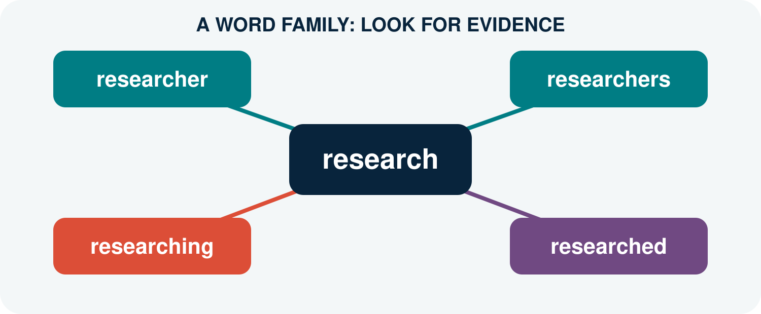
Expression | What repeats? | What is added? | Meaning/function
research
researcher
researchers
researching
researched
Q1. Which form remains stable across the family?

Q2. Which ending is associated with a person?

Q3. Which endings provide grammatical information?

3. MEET THE MORPHEME
Morphology examines smaller, identifiable parts of words. These minimal units of morphological analysis are called morphemes (Carstairs-McCarthy, 2002, p. 16).
A useful first definition
A morpheme is the smallest unit that has a morphological form and a regular contribution to meaning or grammatical function.
Why not simply say ‘the smallest meaningful unit’? Some morphemes express a clear lexical meaning; others mainly perform a grammatical function. Meaning alone may therefore be too narrow (Carstairs-McCarthy, 2002, pp. 16–17).
FORM. Can we identify a stable form?
CONTRIBUTION. Does it contribute meaning or grammatical information?
RECURRENCE. Does it occur in other related words?
CONTRAST. Does adding or removing it create a systematic contrast?
Q4. Using the definition above, propose the morphemes in researcher.

4. ROOT OR AFFIX?
The root is the central part around which a word is built. An affix is attached to another form. In English, an affix before a base is a prefix; an affix after a base is a suffix (Carstairs-McCarthy, 2002, pp. 20–21).
Word | Proposed root | Affix | Your evidence
teacher | teach | -er
unkind | kind | un-
walked | walk | -ed
books | book | -s
Q5. Where would researcher fit in this table?

5. FREE OR BOUND?
A free morpheme can occur as a word by itself. A bound morpheme normally occurs only as part of a larger word (Carstairs-McCarthy, 2002, pp. 18–19).
Form | Free or bound? | Evidence
research
teach
kind
-er
un-
-ed
-s
Q6. Can research occur independently in English? Give a sentence.

Q7. Can person-forming -er normally stand alone with the same function?

6. THE RE- TRAP
The letters re occur at the beginning of rewrite, replay, return, and research. Are they the same morpheme every time?
Word | Possible analysis | Meaning of re-?
rewrite
replay
reheat
return
research
Q8. In which words does re- clearly mean ‘again’ or ‘back’?

Q9. Does modern research mean ‘search again’?

CAREFUL: The history of a word may reveal an older structure, but present-day speakers may analyse the word differently. This unit focuses first on evidence available in present-day English.

7. FOUR TESTS, NOT ONE KNIFE
Test | Question | RESEARCH | ER
Form | Is the proposed part identifiable?
Meaning/function | Does it make a regular contribution?
Word family | Does it recur in related formations?
Contrast | Does it create a systematic difference?
Q10. Apply all four tests. How strong is the analysis research + -er?

8. WORD DETECTIVE LAB
Choose one word from your life: gamer, creator, follower, reader, designer, kindness, replay, or another suitable word.
A. My word:

B. My proposed morphemes:

C. Form evidence:

D. Meaning or function evidence:

E. Related-word evidence:

F. What remains uncertain?

PRIVACY: Use a public or invented example. Record a source only when the example comes from public data.

9. CHECK YOUR UNDERSTANDING
A1. What is a morpheme? Give a careful first definition.

A2. Why is spelling alone not enough to identify a morpheme?

B1. Identify a root and an affix in teacher.

B2. Classify teach and -er as free or bound.

C1. Why may RE | SEARCH | ER be a weak present-day analysis?

D1. Analyse one unfamiliar word and state how confident you are.

10. WHAT CAN YOU DO NOW?
CAN DO 1. I can notice recurring forms in a word family.
CAN DO 2. I can give a careful first definition of morpheme.
CAN DO 3. I can identify a root and an affix in clear examples.
CAN DO 4. I can distinguish free morphemes from bound morphemes.
CAN DO 5. I can test a proposed boundary with more than spelling.
CAN DO 6. I can state uncertainty instead of forcing an analysis.

EXIT REFLECTION
R1. The most useful test today was...

R2. One word I no longer split in the same way is...

R3. One question I will carry into Unit 3 is...

11. NEXT UNIT
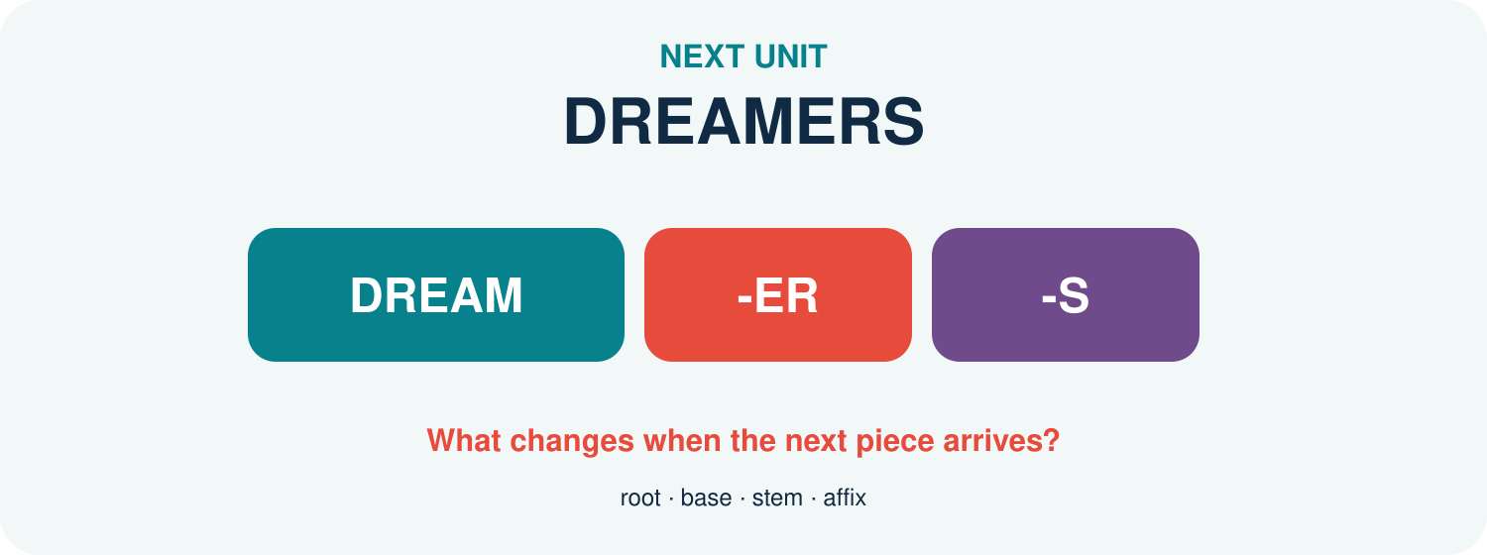
One form can play different roles as a root, base, or stem.
Bring one word from the DREAM family and ask what each added piece changes.

SOURCES USED IN THIS UNIT
Definitions and distinctions in this unit are pedagogical adaptations of the following sources:
Carstairs-McCarthy, A. (2002). An introduction to English morphology: Words and their structure. Edinburgh University Press.
Lieber, R. (2016). Introducing morphology (2nd ed.). Cambridge University Press.
UNIT 3
DREAMERS
What part do these words share?
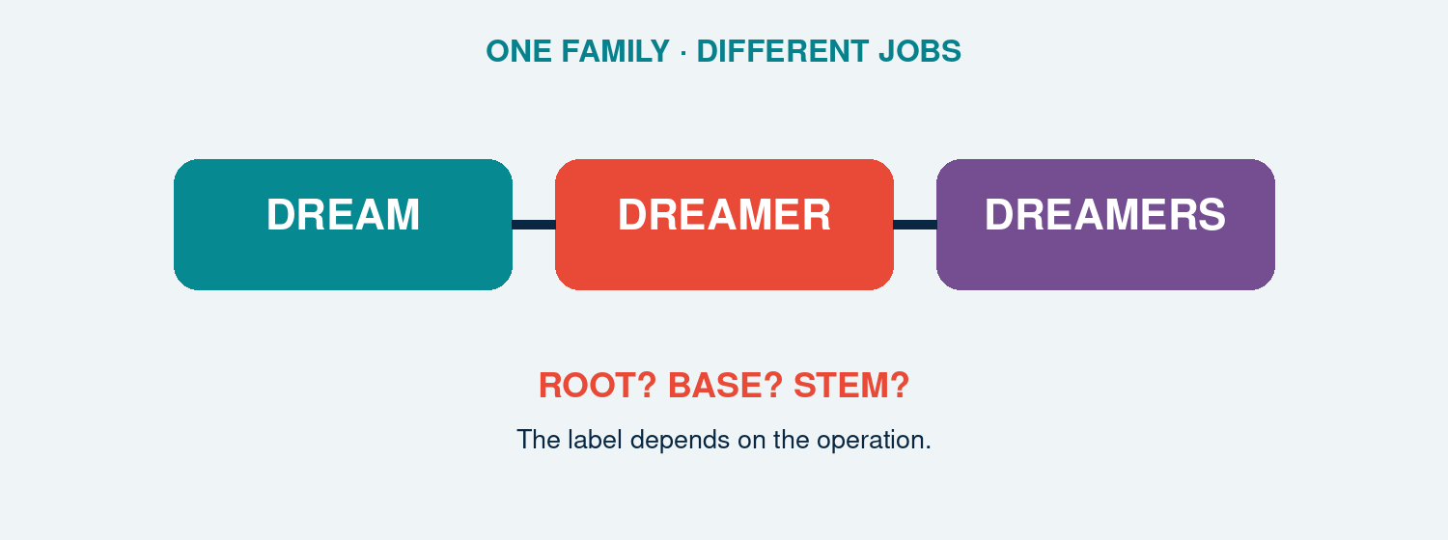
The same form can receive different labels depending on the current morphological operation.
DO NOT MEMORISE THE LABEL FIRST-ASK WHAT THE FORM IS DOING.

YOUR DISCOVERY PATH
In this unit, you will:
 NOTICE the shared material in dream, dreamer, dreamers, dreamy, and daydream.
 DISTINGUISH root, base, stem, and affix by using evidence.
 TRACK what changes at each word-building step.
 COMPARE simple and complex bases.
 TEST whether one form can carry more than one analytical label.
 CREATE a word-family map that another group can challenge.

1. THE FAMILY PHOTO
Circle the shared form. Then underline what is added before or after it.
A. dream
B. dreamer
C. dreamers
D. dreamy
E. daydream
F. daydreamer
Q1. Which form appears in every item?

Q2. Does the shared spelling always have exactly the same structural role? Explain your first hypothesis.

2. FOUR LABELS, FOUR QUESTIONS
ROOT. the core that remains when derivational affixes are removed; it carries the central lexical content.
BASE. any form to which an affix or another morphological operation can apply.
STEM. the base to which an inflectional affix applies in a particular word form.
AFFIX. a bound form attached to a base, such as -er, -y, or plural -s.
These labels identify relations, not four permanently separate objects. In dreamers, dream is a root and a base for -er; dreamer is a base and the stem for plural -s (Bauer et al., 2013; Lieber, 2021).
Step | Form before operation | Operation | Useful label
1 | dream | + -er | root and base
2 | dreamer | + plural -s | base and stem
Q3. Why is dreamer not the root of dreamers?

3. THE LABEL CAMERA
Change the operation and watch the appropriate label change.
dream + -er → dreamer. dream is the root and the base for derivation.
dreamer + -s → dreamers. dreamer is the stem for plural inflection.
day + dream → daydream. day and dream are bases in a compound; dream is the compound head in the usual analysis.
daydream + -er → daydreamer. daydream is a complex base for -er.
dream + -y → dreamy. dream is a base; -y creates an adjective.
Q4. Can a complex form be a base? Use daydreamer as evidence.

Q5. Why is ‘base’ the broadest of the three labels root, base, and stem?

4. BUILD IT IN STEPS
Insert brackets to show the order of construction.
A. dreamers

B. daydreamer

C. dreaminess

D. undreamlike

5. THE ODD ONE OUT
Choose the least structurally similar item. More than one answer may work if the evidence is strong.
dream · dreamer · dreamers · cream Which item lacks the DREAM root?
dreamy · cloudy · friendly · quickly Which suffix or word class makes one item different?
daydream · bedroom · dreamland · dreamer Which item is not a compound?
dreamers · teachers · happiness · creators Which item is not an inflected plural word form?
Q6. Which decision required meaning rather than spelling alone?

6. ROOT OR ACCIDENT?
A repeated letter string is not automatically a morpheme. Compare dream in dreamer with ear in researcher.
Q7. What recurring form–meaning evidence supports dream as a morpheme?

Q8. Why should we reject a split merely because the letters recur?

7. WORD-FAMILY MAP
Build a map from DREAM. Every arrow must name the process and the new category or grammatical value.
CENTRE. Write the root and its basic category:

DERIVATION 1. Add an agent/person suffix:

INFLECTION. Create a plural word form:

DERIVATION 2. Create an adjective:

COMPOUND. Add another free base:

COMPLEX BASE. Attach an affix to the compound:

COUNTEREXAMPLE. Add one tempting but invalid family member:

DEFENCE. Explain why every accepted arrow is justified:

MAP RULE: SHARED SPELLING OPENS THE INVESTIGATION; RECURRING FORM, MEANING, AND DISTRIBUTION SUPPORT THE ANALYSIS.

8. CHECK YOUR UNDERSTANDING
A1. Define root, base, stem, and affix in your own words.

A2. Identify the root, derivational base, and inflectional stem in dreamers.

B1. Explain why daydream is a complex base in daydreamer.

B2. Bracket dreamers and daydreamer.

C1. Evaluate: ‘Every stem is simple.’

C2. Evaluate: ‘A root can never also be a base.’

9. WHAT CAN YOU DO NOW?
CAN DO 1. I can identify recurring morphological material.
CAN DO 2. I can distinguish root, base, stem, and affix.
CAN DO 3. I can track labels across successive operations.
CAN DO 4. I can recognise simple and complex bases.
CAN DO 5. I can reject accidental letter-based segmentation.
CAN DO 6. I can construct and defend a word-family map.

10. NEXT UNIT
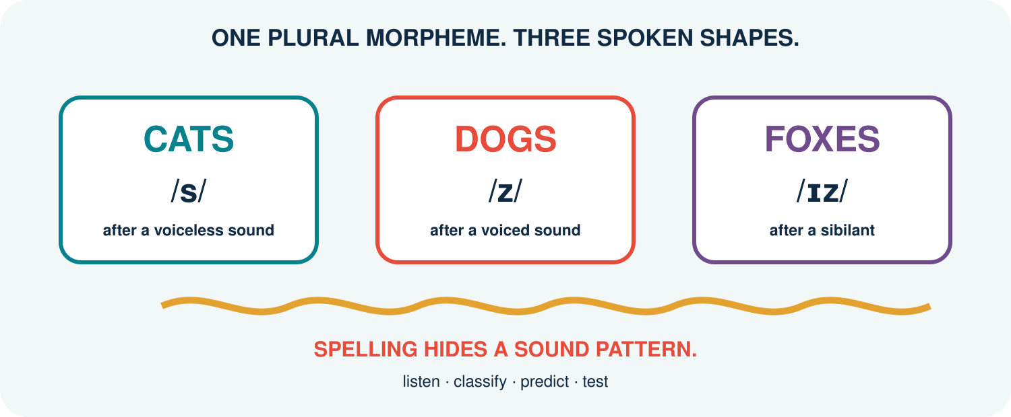
One grammatical morpheme may have several predictable phonological realisations.
They all end in written -s. Listen carefully: the sound pattern is about to change the analysis.

SOURCES USED IN THIS UNIT
Concepts and examples are pedagogical adaptations of the following sources:
Bauer, L., Lieber, R., & Plag, I. (2013). The Oxford reference guide to English morphology. Oxford University Press.
Carstairs-McCarthy, A. (2002). An introduction to English morphology: Words and their structure. Edinburgh University Press.
Lieber, R. (2021). Introducing morphology (3rd ed.). Cambridge University Press.
UNIT 4
CATS · DOGS · FOXES
They all end in “s”. Why don’t they sound the same?

One plural morpheme is realised by different phonological shapes in predictable environments.
LISTEN TO THE LAST SOUND-NOT THE LAST LETTER.

YOUR DISCOVERY PATH
In this unit, you will:
 HEAR three pronunciations of regular plural morphology.
 CONNECT one morpheme with several morphs or allomorphs.
 PREDICT plural -s and past -ed from the phonological environment.
 DISTINGUISH phonological conditioning from spelling and lexical irregularity.
 COMPARE overt, zero, irregular, and suppletive realisations.
 CREATE a Sound Pattern Guide that another learner can test.
1. LISTEN | 2. GROUP | 3. PREDICT | 4. TEST
Say the whole word. | Classify the ending. | Apply the environment. | Try unseen words.

1. THE SOUND POLL
Say each plural naturally. Put it under /s/, /z/, or /ɪz/ before reading any rule.
A. cats
B. dogs
C. foxes
D. books
E. phones
F. dishes
G. TikTokers
H. classes
Q1. Which groups did the class agree on? Which forms were uncertain?

Q2. What sound immediately precedes the plural ending in each word?

FIRST DISCOVERY: THE CHOICE FOLLOWS THE FINAL SOUND OF THE BASE, NOT SIMPLY ITS SPELLING.

2. MORPHEME, MORPH, ALLOMORPH
A morpheme is an abstract minimal unit with a grammatical or lexical function. A morph is a concrete spoken or written realisation. Allomorphs are alternative realisations of the same morpheme in different environments. English regular plural has the allomorphs /s/, /z/, and /ɪz/ in the analysis used here (Carstairs-McCarthy, 2002; Lieber, 2021).
MORPHEME. PLURAL: the grammatical contrast ‘more than one’.
MORPHS. the audible forms /s/, /z/, and /ɪz/.
ALLOMORPHY. different forms realise the same plural morpheme.
CONDITIONING. the phonological environment predicts the regular choice.
Q3. Why are /s/ and /z/ not two different plural morphemes in cats and dogs?

3. THE PLURAL DECISION TREE
Work from the final sound of the singular base.
Environment | Allomorph | Examples | Reason
after a sibilant: /s z ʃ ʒ tʃ dʒ/ | /ɪz/ | buses, dishes, judges | extra vowel separates similar sounds
after another voiceless sound | /s/ | cats, books, cliffs | voicing agrees with environment
after another voiced sound or vowel | /z/ | dogs, rooms, days | voicing agrees with environment
Q4. Why is /ɪz/ selected before the voicing choice?

ORDER OF QUESTIONS: SIBILANT? → /ɪz/. IF NOT: VOICELESS? → /s/. OTHERWISE → /z/.

4. PREDICT BEFORE YOU HEAR
Predict the plural pronunciation of each unfamiliar or playful noun. Then say it naturally and compare.
Base | Final sound | Prediction | Plural
meme
app
vlog
hashtag
quiz
badge
stream
GIF
Q5. Which prediction depends on how the speaker pronounces the base itself?

5. PAST -ED: A SECOND PATTERN
Regular past -ed also has phonologically conditioned allomorphs. Again, listen to the final sound of the verb base.
Environment | Allomorph | Examples | Decision
after /t/ or /d/ | /ɪd/ | wanted, needed | insert a vowel
after another voiceless sound | /t/ | walked, laughed | voiceless agreement
after another voiced sound or vowel | /d/ | played, called | voiced agreement
Q6. Predict the ending in posted, liked, shared, streamed, and vlogged.

DO NOT COUNT LETTERS: liked ends in written -ed but normally adds one consonant sound /t/, not a new syllable.

6. WHEN NOTHING IS AUDIBLE
A grammatical contrast may be present even when no extra segment is heard. A zero realisation is represented as Ø.
ONE SHEEP / TWO SHEEP. SHEEP + PLURAL Ø
ONE DEER / THREE DEER. DEER + PLURAL Ø
I CUT IT TODAY / I CUT IT YESTERDAY. CUT + PAST Ø in the surface form
Q7. What evidence outside the word form identifies plural or past meaning?

Q8. Why is Ø different from saying ‘there is no grammar’?

7. WHEN THE WHOLE FORM CHANGES
Not all alternations are predicted by the regular sound environment.
Relation | Forms | Type | What must be learned?
plural | foot → feet | vowel alternation | lexically restricted pattern
plural | child → children | irregular affix/allomorphy | special form
past | sing → sang | vowel alternation | verb class/form
past | go → went | suppletion | unrelated-looking form
comparison | good → better | suppletion | unrelated-looking form
Q9. Why can the regular plural decision tree not produce feet or children?

8. CONDITIONED OR STORED?
Decide whether the alternation is regularly phonological, zero, irregular but patterned, or suppletive.
Pair | My classification | Evidence | Prediction for new words?
cap/caps
sheep/sheep
mouse/mice
go/went
Q10. Which patterns can confidently extend to a newly coined base?

9. SOUND PATTERN GUIDE
Create a one-page guide for a learner who knows the spelling but mispronounces endings.
TARGET. Plural -s or past -ed:

RULE. Decision sequence in learner-friendly English:

SOUND MAP. Environments and allomorphs:

CORE EXAMPLES. Three examples with IPA:

GEN Z SET. Three current-life examples:

TRAP. One spelling-based mistake to avoid:

EXCEPTION. One zero, irregular, or suppletive contrast:

TEST. Two unseen items for a partner:

REVISION. What changed after partner testing:

LAB RULE: A USEFUL GUIDE MUST PREDICT NEW REGULAR FORMS AND CLEARLY LABEL WHAT IT CANNOT PREDICT.

10. CHECK YOUR UNDERSTANDING
A1. Distinguish morpheme, morph, and allomorph.

A2. State the regular plural decision sequence.

B1. Predict plural allomorphs for apps, memes, and quizzes.

B2. Predict past allomorphs for posted, liked, and shared.

C1. Explain zero realisation with sheep or cut.

C2. Distinguish phonological conditioning from suppletion.

D1. Evaluate: ‘Different pronunciations always signal different morphemes.’

11. WHAT CAN YOU DO NOW?
CAN DO 1. I can connect one morpheme with several allomorphs.
CAN DO 2. I can predict regular plural and past pronunciations.
CAN DO 3. I can use phonological environment rather than final letter.
CAN DO 4. I can recognise zero realisation.
CAN DO 5. I can separate regular conditioning, irregularity, and suppletion.
CAN DO 6. I can design and partner-test a Sound Pattern Guide.

EXIT REFLECTION
R1. The spelling that fooled my ear was...

R2. The rule I can now use predictively is...

R3. The irregular form I need to store is...

12. NEXT UNIT
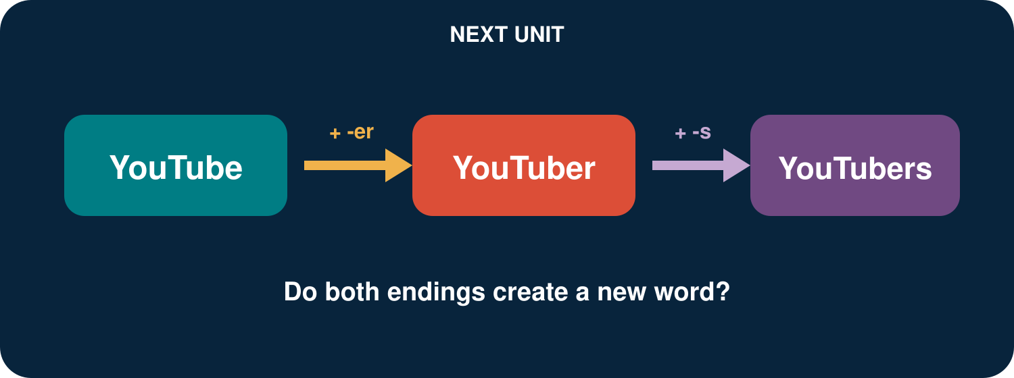
A platform name can grow into a person word and then a plural word form.
Follow YouTube → YouTuber → YouTubers and ask what each step creates.

SOURCES USED IN THIS UNIT
Concepts and examples are pedagogical adaptations of the following sources:
Bauer, L., Lieber, R., & Plag, I. (2013). The Oxford reference guide to English morphology. Oxford University Press.
Carstairs-McCarthy, A. (2002). An introduction to English morphology: Words and their structure. Edinburgh University Press.
Lieber, R. (2021). Introducing morphology (3rd ed.). Cambridge University Press.
UNIT 5
YOUTUBERS
What happened before the final “s”?
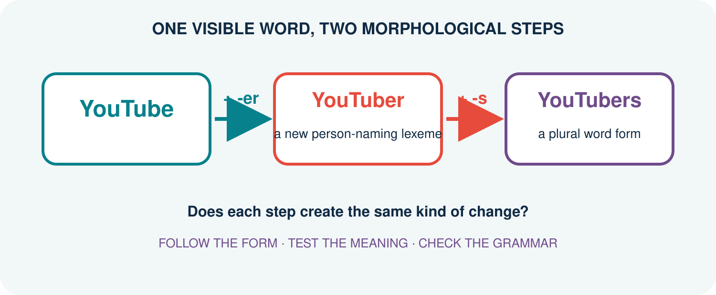
The word records two changes-but the two changes do different work.
FOLLOW THE STEPS. DO NOT LET SPELLING MAKE THE DECISION.

YOUR DISCOVERY PATH
In this unit, you will:
 NOTICE two successive changes inside YouTubers.
 TRACE the pathway YouTube → YouTuber → YouTubers.
 DISTINGUISH a lexeme-building step from a grammar-building step.
 CONNECT derivation with word formation and inflection with paradigms.
 TEST the contrast using creators, teachers, vloggers, and irregular plurals.
 CREATE a mini-profile for a digital identity and all its grammatical forms.
1. TRACE | 2. COMPARE | 3. TEST | 4. CREATE
Rebuild the pathway. | Ask what changed. | Try new evidence. | Build a mini-paradigm.

1. ONE BIO, THREE FORMS
Read this short channel bio. Circle every form related to YouTube.
Linh watches YouTube after class. She is a YouTuber who reviews study apps. Other YouTubers sometimes join her livestreams.
Q1. Which form names a platform? Which form can name one person? Which form can name more than one?

Q2. Put the three forms in an order that shows how the longest form may be built.

FIRST DISCOVERY: The additions -er and -s both change form, but they do not create the same kind of result.

2. REPLAY THE BUILD
Complete each checkpoint before learning the labels.
Step | Result | What changes? | What stays?
YouTube + -er | YouTuber | meaning / category? | core reference?
YouTuber + -s | YouTubers | number / category? | person meaning?
Q3. After which step would a dictionary be more likely to give a new entry?

Q4. After which step are we mainly choosing singular or plural grammar?

3. TWO KINDS OF CHANGE
Derivation forms a new lexeme from an existing base. Inflection produces grammatical word forms of a lexeme without normally creating a new lexeme. A lexeme is an abstract vocabulary item; its word forms are the forms used in sentences (Bauer et al., 2013; Lieber, 2021).
DERIVATION. YouTube + -er → YouTuber: a new person-naming lexeme.
INFLECTION. YouTuber + plural -s → YouTubers: a plural word form of YOUTUBER.
ORDER. Derivation is closer to the base here; plural inflection is added outside it.
WORKING MAP: [[YouTube] + -er] + -s
Q5. Why is *YouTubeser* not the structure expressed by YouTubers?

4. LEXEME OR WORD FORM?
Sort the evidence. Use L for a distinct lexeme and WF for a word form of the same lexeme.
Pair | L or WF? | Your evidence
teach / teacher
teacher / teachers
create / creator
creator / creators
vlog / vlogger
vlogger / vloggers
happy / happier
walk / walked
Q6. Which decision was hardest? What extra context would help?

5. BUILD A MINI-PARADIGM
A paradigm organises the inflected forms associated with a lexeme. English nouns usually contrast singular and plural.
Lexeme | Singular word form | Plural word form
YOUTUBER | YouTuber | YouTubers
CREATOR | creator | creators
CHILD | child | children
SHEEP | sheep | sheep
Q7. Does plural meaning always require the visible ending -s? Use the table as evidence.

IMPORTANT: INFLECTION IS A GRAMMATICAL RELATION, NOT SIMPLY A STRING OF LETTERS.

6. WHEN S IS NOT PLURAL
Read each sentence. Decide what the final s is doing.
A. Two YouTubers collaborate every Friday.
B. Linh watches their videos.
C. The YouTuber’s camera is new.
D. News travels fast online.
Q8. Which s marks noun plural, which marks present-tense agreement, and which marks possession?

Q9. Why should news not be analysed as new + plural -s in this sentence?

7. A SCALE, NOT A CHECKLIST
The derivation–inflection contrast is strong, but no single test decides every case. Combine several clues.
Clue | More derivational | More inflectional
Main job | builds a lexeme | expresses grammar
Meaning | may be less predictable | usually regular and grammatical
Word class | may change | normally stays
Productivity | varies by affix/base | often required where grammar calls for it
Position | usually inside inflection | usually outside derivation
Q10. Which two clues best explain -er and plural -s in YouTubers?

8. THE ORDER CHALLENGE
Build each word one card at a time. Draw brackets to show which two pieces combine first.
A. teach + -er + -s → teachers
B. vlog + -er + -s → vloggers
C. un- + help + -ful → unhelpful
D. modern + -ise + -ed → modernised
Q11. Which examples end in inflection? Which contain only derivation?

Q12. What interpretation problem appears if the affixes are attached in the wrong order?

9. DIGITAL IDENTITY LAB
Choose a real or invented platform/activity base: stream, game, vlog, podcast, review-or another responsible example.
A. My base and what it refers to:

B. My person-naming derived lexeme:

C. Its singular and plural word forms:

D. A sentence containing each form:

E. Bracketing for the plural form:

F. Evidence that another student understands it:

G. Status: established / emerging / invented:

ETHICS CHECK: Use public language data; do not expose private usernames, messages, or personal details.

10. CHECK YOUR UNDERSTANDING
A1. What is a lexeme?

A2. What is a word form?

B1. Explain why YouTube → YouTuber is derivational.

B2. Explain why YouTuber → YouTubers is inflectional.

C1. Bracket vloggers and describe each step.

C2. Give one plural without visible -s and explain its value as evidence.

D1. Evaluate the claim: ‘Every final s is a plural morpheme.’

11. WHAT CAN YOU DO NOW?
CAN DO 1. I can trace more than one morphological step in a word.
CAN DO 2. I can distinguish a lexeme from its word forms.
CAN DO 3. I can contrast derivation with inflection using several clues.
CAN DO 4. I can build a simple noun paradigm.
CAN DO 5. I can avoid analysing every final s as plural.
CAN DO 6. I can create and test a digital identity formation.

EXIT REFLECTION
R1. Before this unit, I thought every added ending...

R2. The strongest evidence I used today was...

R3. One word I now want to investigate is...

12. NEXT UNIT
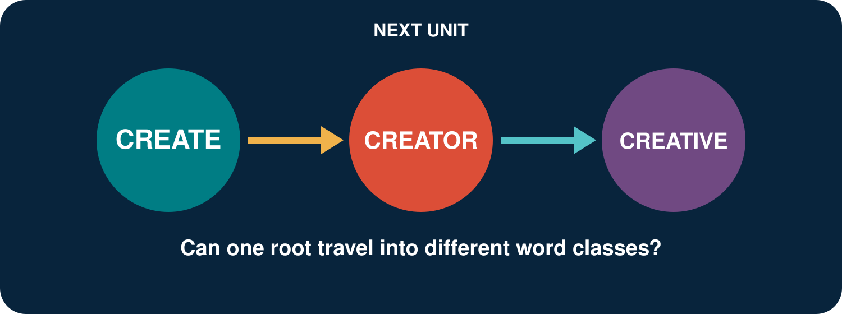
One root can grow into nouns, adjectives, and abstract nouns.
Follow CREATE through a family of related lexemes.

SOURCES USED IN THIS UNIT
Concepts and examples are pedagogical adaptations of the following sources:
Bauer, L., Lieber, R., & Plag, I. (2013). The Oxford reference guide to English morphology. Oxford University Press.
Carstairs-McCarthy, A. (2002). An introduction to English morphology: Words and their structure. Edinburgh University Press.
Lieber, R. (2021). Introducing morphology (3rd ed.). Cambridge University Press.
UNIT 6
CREATOR
How many words can grow from “create”?
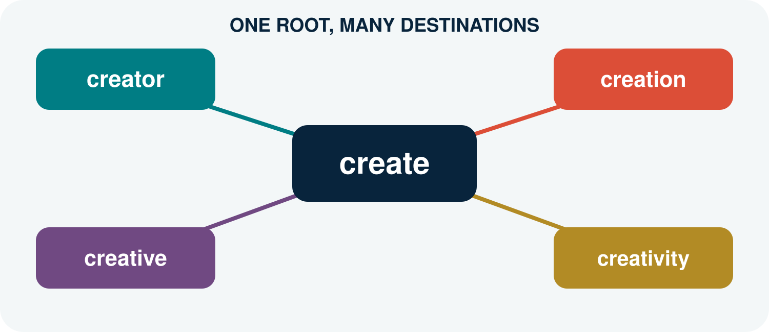
A word family shares material, but its members may not share the same grammatical job.
FOLLOW THE ROOT. WATCH THE WORD CLASS CHANGE.

YOUR DISCOVERY PATH
In this unit, you will:
 NOTICE how related forms behave in real sentences.
 CLASSIFY create, creator, creation, and creative by word class.
 CONNECT suffixes with changes in meaning and grammatical function.
 EXPLAIN derivation as a process that forms a new lexeme.
 TEST whether a proposed family member is possible, understandable, and natural.
 DESIGN a word-family passport for a root of your choice.
1. USE | 2. CLASSIFY | 3. CONNECT | 4. CREATE
Meet words in context. | Name their word classes. | Link form, meaning, and job. | Extend a word family.

1. THREE LINES, THREE JOBS
Read the three lines as if they appeared in a student media project.
A. We create short videos for language learners.
B. Mai is the creator of the channel.
C. Her most creative idea uses street interviews.
Q1. Which highlighted word expresses an action?

Q2. Which word names a person?

Q3. Which word describes an idea?

Q4. What material is shared by all three words?

FIRST DISCOVERY: Related forms may share a root while performing different grammatical jobs.

2. BUILD THE FAMILY MAP
Use the cover map as your visual guide. Complete the analytical map below.
Form | Word class | Core contribution | Possible context
create
creator
creation
creative
creativity
Q5. Which forms are nouns? Which form is normally a verb? Which form is commonly an adjective?

3. WHAT IS DERIVATION?
Derivation is a morphological process that forms a new lexeme from an existing base. It may change word class, meaning, or both. English derivation commonly uses prefixes and suffixes (Carstairs-McCarthy, 2002, pp. 44–45; Lieber, 2016).
A working idea
BASE + DERIVATIONAL AFFIX → A NEW MEMBER OF A WORD FAMILY
create + -or → creator: a person or entity that creates
create + -ion → creation: an act, process, or result of creating
create + -ive → creative: having the quality or ability to create
Q6. What changes in each pathway: form, word class, meaning, or more than one?

4. THE SUFFIX LEAVES A SIGN
In many English derived words, a suffix helps determine the word class of the whole word. Compare several families before proposing a pattern.
Base | Suffix | Derived form | Word class
act | -or | actor | noun
visit | -or | visitor | noun
create | -ive | creative | adjective
attract | -ive | attractive | adjective
create | -ion | creation | noun
educate | -ion | education | noun
Q7. What word class is regularly associated with each suffix in this table?

CAREFUL: A useful pattern is not a promise that every imaginable combination is an established English word.

5. WHERE DID THE E GO?
The family contains create, creator, creation, and creative. The spelling of the base is not visually identical in every member.
COMPARE. create → creator; create → creation; create → creative
Q8. Which letters remain stable? Which final letter disappears before some suffixes?

Q9. Does the missing e mean that create is no longer the relevant base? Explain.

SPELLING NOTE: A spelling adjustment at a morpheme boundary does not automatically create, remove, or replace a morpheme. Analyse form together with meaning and word-family relationships.

6. SAME ROOT, DIFFERENT MEANINGS
A word family is systematic, but its meanings are not always fully predictable from a short formula.
CREATOR. may refer to a person, an organisation, or a digital content producer.
CREATION. may refer to a process or to the thing produced.
CREATIVE. usually functions as an adjective, but can also be used as a noun for a creative professional in some contexts.
CREATIVITY. names an abstract quality or ability.
Q10. Why is ‘suffix meaning’ better treated as a contribution than as a complete dictionary definition?

7. DOES THE PATTERN TRAVEL?
Starting form | Person noun | Adjective | Abstract noun
act | actor | active | activity
invent | inventor | inventive | invention
produce | producer | productive | production
compete | competitor | competitive | competition
Q11. Which family is most similar to create? Which differences do you notice?

Q12. Do all person nouns use the same suffix spelling?

PATTERN, NOT COOKIE CUTTER: Word families show regularities, spelling adjustments, and lexical choices at the same time.

8. FAMILY OR STRANGER?
Decide whether each form is (a) an established family member, (b) understandable but uncertain, or (c) unsupported in the intended meaning.
Form | My decision | Evidence or question
creator
creation
creative
creativity
creatively
creatist
creatorful
recreate
Q13. Which uncertain form would you check in a dictionary or corpus first? Why?

9. WORD-FAMILY PASSPORT
Choose a root connected with your life or studies: design, teach, learn, play, compete, invent, connect-or another suitable root.
A. My root and its basic word class:

B. Family member 1: form, class, and meaning:

C. Family member 2: form, class, and meaning:

D. Family member 3: form, class, and meaning:

E. A spelling change I notice:

F. One uncertain or possible new member:

G. How I would verify it:

CREATIVITY CHECK: Invent freely, but label the difference between an established word, an understandable innovation, and an unsupported guess.

10. CHECK YOUR UNDERSTANDING
A1. What is derivation?

A2. How can derivation change word class? Give an example.

B1. Analyse creator and creative into a base and suffix.

B2. Why should spelling change not be confused with morpheme change?

C1. Why may two members of one word family have partly unpredictable meanings?

D1. Build and evaluate one new family member from a root not used in this unit.

11. WHAT CAN YOU DO NOW?
CAN DO 1. I can recognise a derivational word family.
CAN DO 2. I can classify common family members by word class.
CAN DO 3. I can connect suffixes with regular contributions.
CAN DO 4. I can separate spelling adjustments from morphemes.
CAN DO 5. I can test whether a pattern travels to new data.
CAN DO 6. I can create and verify a word-family passport.

EXIT REFLECTION
R1. The family member that surprised me most was...

R2. A suffix I can now use more carefully is...

R3. One invented word I would like to test is...

12. NEXT UNIT
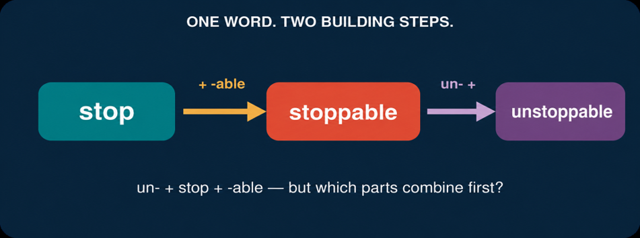
A complex word may be built in more than one step.
Decide which two parts of UNSTOPPABLE join first.

SOURCES USED IN THIS UNIT
Concepts and examples in this unit are pedagogical adaptations of the following sources:
Carstairs-McCarthy, A. (2002). An introduction to English morphology: Words and their structure. Edinburgh University Press.
Lieber, R. (2016). Introducing morphology (2nd ed.). Cambridge University Press.
Bauer, L., Lieber, R., & Plag, I. (2013). The Oxford reference guide to English morphology. Oxford University Press.
UNIT 7
UNSTOPPABLE
Which two parts joined first?

The letters are visible. The building history must still be discovered.
WORDS HAVE PARTS-AND PARTS CAN HAVE PARTS.

YOUR DISCOVERY PATH
In this unit, you will:
 NOTICE that complex words may be built in stages.
 RECONSTRUCT the pathway from stop to unstoppable.
 DISTINGUISH root, base, and stem in clear contexts.
 REPRESENT word structure with brackets and a simple tree.
 TEST how different structures can produce different meanings.
 CREATE and justify a multi-step word formation.
1. BUILD | 2. NAME | 3. REPRESENT | 4. TEST
Reconstruct the stages. | Identify root and bases. | Draw brackets or a tree. | Use meaning as evidence.

1. PRESS PAUSE
Imagine that unstoppable appears in a motivational post: ‘Small steps can make you unstoppable.’ Do not divide the word yet.
A. What does unstoppable mean in this sentence?

B. Which familiar word can you see inside it?

C. Which parts appear before or after that word?

D. Do you think all parts were added at the same time? Why?

FIRST HYPOTHESIS: A complex word may contain a smaller word that was built earlier.

2. REBUILD THE WORD

Stage | Input | Operation | Output
1 | stop | add -able | stoppable
2 | stoppable | add un- | unstoppable
Q1. What does -able contribute at Stage 1?

Q2. What does un- contribute at Stage 2?
Q3. Why must stoppable be available before un- can be added in this analysis?

3. ROOT, BASE, OR STEM?
These three labels answer different questions. A root is the central lexical element of a non-compound word. A base is any form to which an affix is added. Stem is used in several ways, but often refers to the form that receives an inflectional affix (Carstairs-McCarthy, 2002, Glossary).
Term | Working meaning | Example in this unit
root | central lexical element | stop
base | input to an affixation step | stop; stoppable
stem | base for an inflectional form | stop in stopped
The same form may receive different labels because root, base, and stem describe different roles in an analysis.
Q4. In the formation stoppable, what is the root and what is the base for -able?

Q5. In the formation unstoppable, what is the base for un-?

4. ONE LETTER, TWO JOBS?
Look closely: stop → stoppable. The spelling contains pp. Does the second p express a new meaning or grammatical function?
Q6. How many morphemes are in stoppable in the present analysis?

Q7. Is the extra written p a morpheme? Explain.

SPELLING NOTE: English doubles the final consonant in forms such as stopped and stopping. The extra letter helps represent a spelling pattern; it is not an additional morpheme.
COMPARE. hope → hopeful; stop → stoppable; plan → planned; open → opened
Q8. What spelling conditions might be relevant? State a cautious observation, not a final rule.

5. FLAT OR LAYERED?
A flat analysis lists three morphemes: un- + stop + -able. A layered analysis also shows which parts combine first. Multiple-affix words are built by successive processes, and the intermediate form is a constituent inside the larger word (Carstairs-McCarthy, 2002, pp. 72–74).
Flat list | Layered structure
un- + stop + -able | [un- [stop + -able]]
Q9. Which representation shows the first building step?

Q10. What meaning belongs to the inner unit [stop + -able]?

6. BRACKETS THAT TELL A STORY
Brackets can record the order of construction:
[un- [stop + -able]]
INNER BRACKETS. stop combines with -able: ‘able to be stopped’.
OUTER BRACKETS. un- combines with stoppable: ‘not stoppable’.
WHOLE WORD. the outermost brackets represent unstoppable.
Q11. Add brackets to unkindness if the pathway is kind → unkind → unkindness.

Q12. Add brackets to reusable if the pathway is use → reusable. Which affix is added first?

7. A SMALL TREE
A simple word tree displays the same grouping vertically. Each branching point represents a constituent.
Level | Constituent | Contribution
Whole | unstoppable | not stoppable
Inner | stoppable | able to be stopped
Q13. Draw a two-level tree for unstoppable. Label the root and both affixes.

8. UNLOCKABLE: STRUCTURE CHANGES MEANING
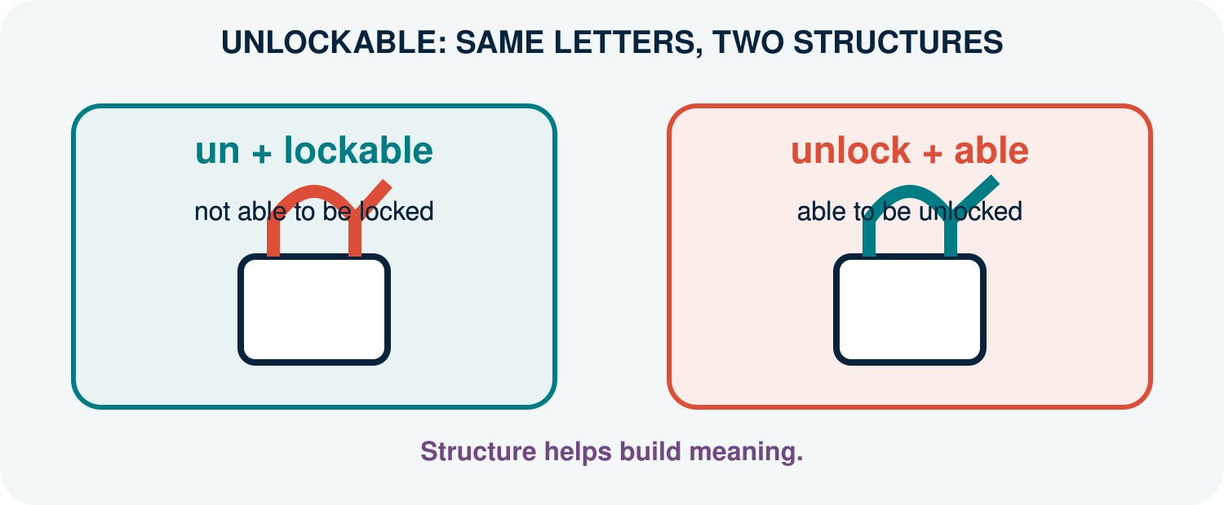
The same written form can support two interpretations when speakers build it from different intermediate bases.
Q14. Which structure matches ‘not able to be locked’?

Q15. Which structure matches ‘able to be unlocked’?

Q16. Write a short sentence that makes each meaning clear.

BIG IDEA: Morpheme order is not enough. Grouping helps explain meaning.

9. BUILDING LAB
Choose one pathway or create a similar one: use → reusable; agree → disagreeable; hope → hopelessness; teach → unteachable.
A. My final word:

B. My root:

C. First building step:

D. Second building step:

E. Bracketed structure:

F. How does each step change meaning or function?

G. What evidence makes my analysis convincing?

CREATIVITY CHECK: A new word is stronger when another person can reconstruct its pathway and intended meaning.

10. CHECK YOUR UNDERSTANDING
A1. Explain the difference between a root and a base.

A2. Why can one word contain more than one base during its construction?

B1. Give the two stages in stop → unstoppable.

B2. Why is the extra p in stoppable not a morpheme?

C1. What information do brackets add to a list of morphemes?

D1. Explain the two meanings of unlockable using two structures.

11. WHAT CAN YOU DO NOW?
CAN DO 1. I can reconstruct a word in successive steps.
CAN DO 2. I can identify a root and the base at each step.
CAN DO 3. I can distinguish a spelling change from a morpheme.
CAN DO 4. I can represent layered structure with brackets.
CAN DO 5. I can use structure to explain meaning.
CAN DO 6. I can create and defend a multi-step formation.

EXIT REFLECTION
R1. Before this unit, I thought affixes...

R2. Now I understand that word structure...

R3. One word whose layers I want to investigate is...

12. NEXT UNIT
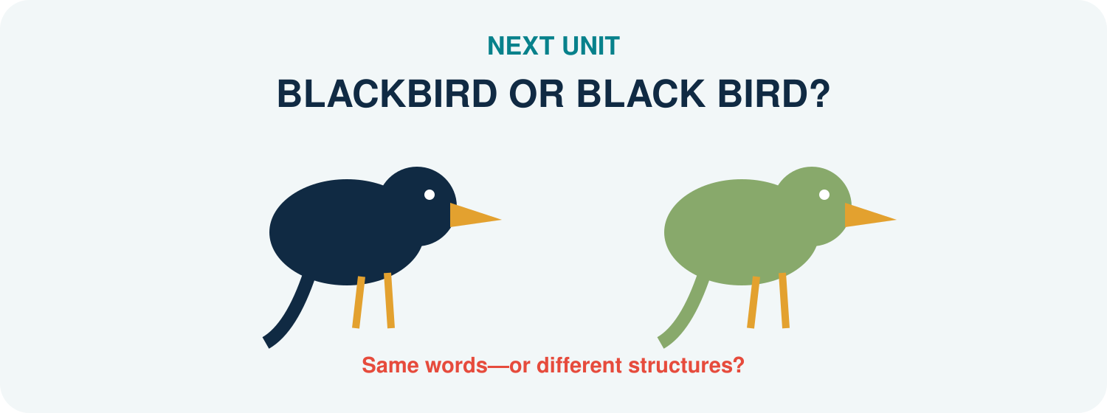
The same two words can form one compound or remain a phrase.
Listen and compare: BLACKBIRD or BLACK BIRD?

SOURCES USED IN THIS UNIT
Concepts and representations in this unit are pedagogical adaptations of the following sources:
Carstairs-McCarthy, A. (2002). An introduction to English morphology: Words and their structure. Edinburgh University Press.
Lieber, R. (2016). Introducing morphology (2nd ed.). Cambridge University Press.
UNIT 8
BLACKBIRD OR BLACK BIRD?
Same bird? Same meaning?
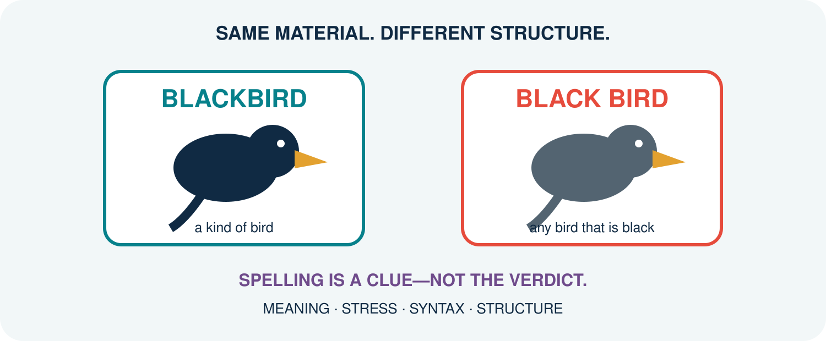
The same two forms may build one compound or a phrase.
COLLECT CLUES. LET THE EVIDENCE CONVERGE.

YOUR DISCOVERY PATH
In this unit, you will:
 NOTICE that blackbird and black bird can point to different categories of things.
 COMPARE compound words with adjective–noun phrases.
 LISTEN for stress differences without treating stress as an automatic answer.
 TEST structure through modification, coordination, meaning, and syntax.
 EXPLAIN head–modifier relations in English compounds.
 CREATE a field guide entry and defend an analysis with converging evidence.
1. SEE | 2. LISTEN | 3. TEST | 4. DEFEND
Compare referents. | Mark prominence. | Try structural probes. | Argue from evidence.

1. TWO BIRDS ENTER THE CHAT
Read the messages. Do not use spelling alone.
A. I saw a blackbird in the garden. Its feathers were dark brown.
B. I saw a black bird at the lake. It was a black swan.
C. That blackbird is not completely black.
Q1. In which message does the expression name a recognised kind of bird?

Q2. In which message does black simply describe colour?

Q3. Why is message C not necessarily contradictory?

FIRST DISCOVERY: A compound may name a category whose members do not match a literal description perfectly.

2. ONE WORD OR TWO?
A compound is a lexeme formed from two or more bases. A phrase is built by syntax from separate words. English compound spelling may be closed, hyphenated, or open, so spacing is useful evidence but not a complete definition (Bauer et al., 2013; Lieber, 2021).
COMPOUND. blackbird: black modifies the head bird inside one lexical unit.
PHRASE. black bird: the adjective black modifies the noun bird in syntax.
HEAD. bird is the head in both; it supplies the main category and core reference.
Q4. What does the head tell us about the word class and general meaning of blackbird?

3. THE MEANING TEST
Compare literal description with category naming.
Expression | Likely reading | Must X be literal? | Your example
blackbird | kind of bird | not fully
black bird | bird with black colour | normally yes
greenhouse | structure for growing plants | no
green house | house that is green | yes
Q5. Which two items have meanings that are less compositionally transparent?

4. LISTEN FOR THE BEAT
In many English noun compounds, the first element receives stronger prominence; in adjective–noun phrases, the noun may receive stronger prominence. Say the pairs naturally in context.
A. a BLACKbird / a black BIRD
B. a GREENhouse / a green HOUSE
C. a DARKroom / a dark ROOM
Q6. Underline the strongest syllable in each reading. Does your pronunciation support the intended meaning?

CAREFUL: Stress varies with dialect, contrast, and context. Use it with other evidence, not as a one-test verdict.

5. TRY TO GET INSIDE
Phrases are structurally more open than compounds. Test whether a word can naturally enter the expression without changing the intended category reading.
Probe | Result | What it suggests
a very black bird | natural colour phrase | phrase
a very blackbird | not the intended noun | compound resists insertion
a bright green house | natural colour phrase | phrase
a bright greenhouse | bright modifies whole compound | compound remains intact
Q7. Why does a bright greenhouse not mean that bright has entered green + house?

6. COORDINATION AND CONTRAST
Try replacing or coordinating only the descriptive adjective.
A. a black and white bird
B. a green or blue house
C. a black- and songbird
D. a green- and glasshouse
Q8. Which examples naturally coordinate adjectives inside a phrase?

Q9. Why are C and D awkward for the intended compound readings?

7. THE EVIDENCE BOARD
No single clue is perfect. Record whether each clue supports compound, phrase, or remains uncertain.
Clue | BLACKBIRD | BLACK BIRD | Strength / limit
Category meaning
Stress
Internal insertion
Coordination
Spelling
Q10. Which conclusion is supported by the greatest number of independent clues?

8. GREENHOUSE: REPLICATION TEST
A good analysis should travel to new data. Apply the same investigation to greenhouse / green house.
A. Write one sentence for the plant-building reading:

B. Write one sentence for the colour reading:

C. Predict and mark stress:

D. Try one insertion test:

E. Try one coordination test:

F. State your conclusion and strongest evidence:

REPLICATION RULE: Do not change the test after seeing the result. Apply comparable probes to both readings.

9. COMPOUND FIELD GUIDE
Choose a student-relevant pair: smartphone / smart phone, darkroom / dark room, software / soft ware, or another responsible example.
A. My candidate pair and two intended readings:

B. The head and modifier:

C. Meaning evidence:

D. Stress evidence:

E. One syntactic probe:

F. Spelling evidence and its limitation:

G. Verdict: compound / phrase / uncertain:

10. CHECK YOUR UNDERSTANDING
A1. What is a compound?

A2. What is the head of blackbird, and what does it contribute?

B1. Give two differences between blackbird and black bird.

B2. Why can spelling not decide compoundhood by itself?

C1. Use at least three clues to analyse greenhouse.

C2. Explain why a very black bird is more natural than *a very blackbird* for the intended readings.

D1. Evaluate: ‘If an expression is written with a space, it cannot be a compound.’

11. WHAT CAN YOU DO NOW?
CAN DO 1. I can distinguish compound and phrasal readings.
CAN DO 2. I can identify a compound head and modifier.
CAN DO 3. I can use meaning, stress, and syntax as converging evidence.
CAN DO 4. I can explain why orthography is only one clue.
CAN DO 5. I can replicate an analysis with greenhouse / green house.
CAN DO 6. I can defend a classification while allowing uncertainty.

EXIT REFLECTION
R1. The clue I trusted too much before this unit was...

R2. The strongest clue in my investigation was...

R3. One expression I now hear or see differently is...

12. NEXT UNIT
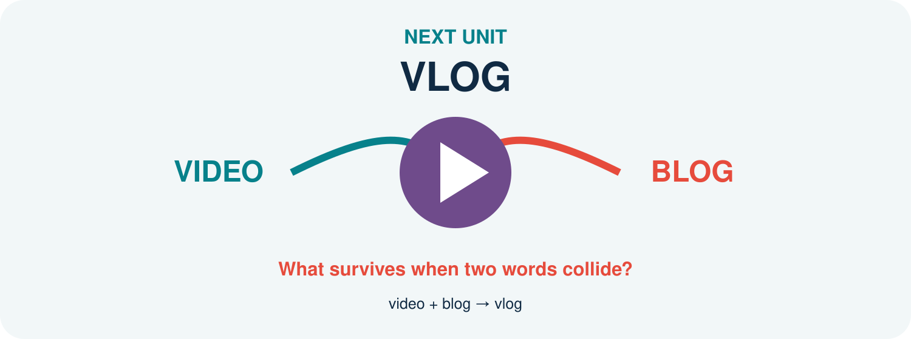
Two source words lose material and create a compact new form.
Track the pieces: what disappeared, what survived, and what changed?

SOURCES USED IN THIS UNIT
Concepts and examples are pedagogical adaptations of the following sources:
Bauer, L., Lieber, R., & Plag, I. (2013). The Oxford reference guide to English morphology. Oxford University Press.
Carstairs-McCarthy, A. (2002). An introduction to English morphology: Words and their structure. Edinburgh University Press.
Lieber, R. (2021). Introducing morphology (3rd ed.). Cambridge University Press.
Plag, I. (2018). Word-formation in English (2nd ed.). Cambridge University Press.
UNIT 9
VLOG
What happened to “video” and “blog”?
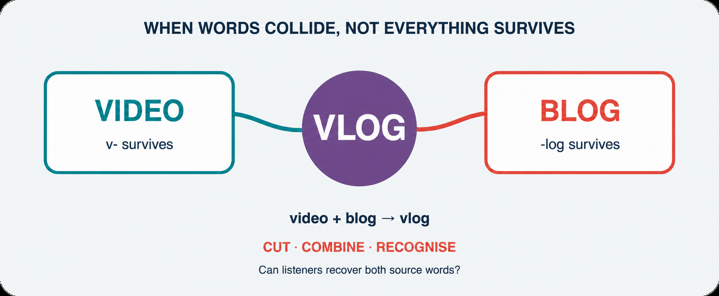
A blend preserves recognisable pieces while forming a new lexical whole.
TRACE WHAT DISAPPEARED. EXPLAIN WHAT SURVIVED.

YOUR DISCOVERY PATH
In this unit, you will:
 NOTICE that vlog contains recognisable material from two source words.
 TRACE what is retained, shortened, overlapped, or lost.
 DISTINGUISH blending from compounding, clipping, acronyms, and initialisms.
 FOLLOW a new lexeme as it develops into vlogger, vlogs, and vlogging.
 TEST whether a proposed formation is recoverable, useful, and natural.
 CREATE a responsible blend and document how an audience interprets it.
1. SPLIT | 2. COMPARE | 3. FOLLOW | 4. CREATE
Recover sources. | Name the process. | Extend the lexeme. | Test a new blend.

1. PAUSE THE VLOG
Read the post. Underline every form related to vlog.
I vlog about campus food. Yesterday’s vlog reached 2,000 views. Two vloggers replied, and one is vlogging from the new library today.
Q1. Which form names a type of video? Which form names a person? Which forms behave as verbs?

Q2. Which word seems historically prior inside this small family?

FIRST DISCOVERY: One creative formation can become the base for later derivation, conversion, and inflection.

2. RECOVER THE SOURCES
Mark the letters or sounds that survive in each result.
Source 1 | Source 2 | Result | Surviving material
video | blog | vlog | v- + -log
breakfast | lunch | brunch | br- + -unch
smoke | fog | smog | sm- + -og
web | seminar | webinar | web + -inar
Q3. Do all blends cut their source words at the same place?

3. WHAT IS A BLEND?
A blend is a word-formation product that combines material from two or more source words while at least one source is shortened. Speakers normally recover contributions from both sources. The exact boundaries may be fuzzy or overlapping (Bauer et al., 2013; Lieber, 2021).
FORM. video and blog lose material in vlog.
MEANING. vlog combines the ideas of video and blog.
LEXICAL RESULT. VLOG functions as a new lexeme, not merely an accidental letter sequence.
Q4. What two kinds of evidence connect vlog with both source words?

4. NOT EVERY SHORT WORD IS A BLEND
Classify each formation by how it is built.
Formation | Source(s) | Process | Reason
app | application | clipping | one source shortened
brunch | breakfast + lunch | blend | two shortened sources
smartphone | smart + phone | compound | two bases retained
NASA | initial letters | acronym | pronounced as a word
DM | direct message | initialism | letters pronounced separately
vlog | video + blog | blend | two sources combined
Q5. Which contrast depends on pronunciation rather than spelling alone?

5. THE BOUNDARY MAY BLUR
Some formations resist a single neat cut. Investigate overlap and multiple plausible analyses.
MOTEL. motor + hotel: the sequence o may feel shared.
EDUTAINMENT. education + entertainment: a long source is reshaped.
INFOTAINMENT. information + entertainment: speakers may recognise a productive -tainment pattern.
VLOG. video + blog: analyses may identify v- or vi- as the first contribution.
Q6. Why is it safer to show recoverable source material than to claim one perfect morpheme boundary?

CAREFUL: A blend’s source pieces are not automatically ordinary affixes or morphemes with stable boundaries.

6. VLOG STARTS A FAMILY
Once vlog is established, familiar morphological processes can treat it as a base.
Form | Likely analysis | Process | Sentence job
vlog | VLOG | blend; noun/verb conversion | noun or verb
vlogger | vlog + -er | derivation | person noun
vloggers | [vlog + -er] + -s | derivation + inflection | plural noun
vlogged | vlog + -ed | inflection | past verb
vlogging | vlog + -ing | inflection in context | verb form
Q7. Why is vlogger not itself a blend?

Q8. What spelling adjustment appears before -ed and -ing?

7. SAME FORM, NEW JOB
English often allows conversion: a lexeme enters a new word class without a visible derivational affix.
NOUN. We posted a vlog.
VERB. We vlog every Friday.
NOUN. Send me a DM.
VERB. DM me the link.
Q9. What sentence evidence distinguishes noun from verb uses?

Q10. Does zero visible affix mean that no morphological change is worth analysing? Explain.

8. BLEND OR BRAND TRAP?
A creative label may resemble a blend without clearly activating two source words. Evaluate-not guess.
Candidate | Possible sources | Recoverable? | Evidence needed
studygram
workation
mockumentary
staycation
glamping
Q11. Which candidate would you verify first in a dictionary or corpus? Why?

9. THE BLEND LAB
Design a word for a real student experience. Avoid using names or private data.
A. The experience or object I want to name:

B. Source word 1 and retained material:

C. Source word 2 and retained material:

D. My proposed blend and pronunciation:

E. Intended meaning in one sentence:

F. Audience test: what did two classmates infer?

G. Revision after the test:

H. Status: invented / attested / established:

CREATIVITY CHECK: A clever form is not enough. The audience must recover the intended sources and meaning with reasonable effort.

10. CHECK YOUR UNDERSTANDING
A1. Define blending in your own words.

A2. Explain why app is a clipping but vlog is a blend.

B1. Recover the sources of brunch, smog, and webinar.

B2. Why may blend boundaries be difficult to segment exactly?

C1. Analyse vloggers from source words to final plural form.

C2. Use sentence evidence to distinguish noun vlog from verb vlog.

D1. Evaluate one candidate from Section 8 using form, meaning, and evidence.

11. WHAT CAN YOU DO NOW?
CAN DO 1. I can recover source words from a blend.
CAN DO 2. I can distinguish blending from four neighbouring processes.
CAN DO 3. I can allow overlap and uncertain boundaries in analysis.
CAN DO 4. I can trace vlog into derived and inflected forms.
CAN DO 5. I can identify conversion through sentence context.
CAN DO 6. I can create, audience-test, and revise a blend.

EXIT REFLECTION
R1. The most surprising loss of material was...

R2. The distinction I can now defend is...

R3. My blend improved when my audience...

12. NEXT UNIT

The parts are visible, but the whole does not describe an actual worm.
If meaning is more than addition, where does the extra meaning come from?

SOURCES USED IN THIS UNIT
Concepts and examples are pedagogical adaptations of the following sources:
Bauer, L., Lieber, R., & Plag, I. (2013). The Oxford reference guide to English morphology. Oxford University Press.
Lieber, R. (2021). Introducing morphology (3rd ed.). Cambridge University Press.
Plag, I. (2018). Word-formation in English (2nd ed.). Cambridge University Press.
Merriam-Webster. (n.d.). Vlog. In Merriam-Webster.com dictionary. Retrieved July 16, 2026, from https://www.merriam-webster.com/dictionary/vlog
UNIT 10
BOOKWORM
Where is the worm?
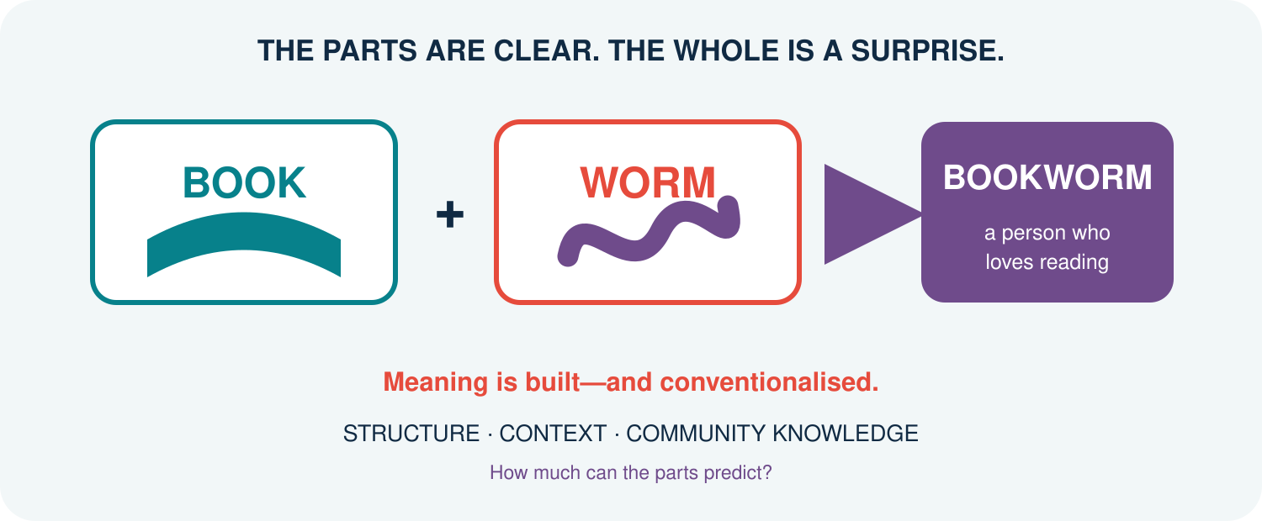
Structure offers a route into meaning, but convention completes the journey.
ADD THE PARTS. THEN ASK WHAT THE COMMUNITY ADDED.

YOUR DISCOVERY PATH
In this unit, you will:
 NOTICE the gap between literal part meanings and conventional whole meanings.
 MAP how book and worm contribute to bookworm.
 PLACE complex words on a transparency–opacity continuum.
 CONNECT polysemy and context with morphological interpretation.
 TEST whether a new listener can infer a meaning from form alone.
 CREATE a context-rich Meaning Map for a familiar or emerging expression.
1. PREDICT | 2. CHECK | 3. MAP | 4. EXPLAIN
Build a literal guess. | Read the context. | Rate transparency. | Defend the meaning.

1. DRAW IT LITERALLY
Before reading a definition, draw or describe what the parts seem to predict.
A. book + worm
B. keyboard
C. greenhouse
D. hot dog
Q1. Which literal picture is closest to the conventional meaning? Which is furthest away?

NOW READ: Mai finishes three novels a week. Everyone in her class calls her a bookworm.
Q2. What does bookworm mean here? What role does worm still seem to play?

FIRST DISCOVERY: The parts constrain interpretation, but context and convention may supply a non-literal relation.

2. MEANING IS NOT SIMPLE ADDITION
Compositionality is the extent to which the meaning of a complex expression can be worked out from the meanings of its parts and the way they are combined. Many complex words are partly predictable rather than completely transparent or completely opaque (Bauer et al., 2013; Lieber, 2021).
FORM. bookworm has the visible structure book + worm.
PREDICTABLE CORE. book directs us toward reading or books.
CONVENTIONAL LINK. worm contributes a figurative image of persistent immersion, not an actual animal.
WHOLE. the established meaning is a person who reads a great deal or loves books.
Q3. Which part of the meaning could a new learner predict most easily?

3. A CONTINUUM, NOT TWO BOXES
Place each item on a line from more transparent to more opaque. Be ready to revise after seeing context.
Expression | Part meanings | Whole meaning | My rating 1–5
classroom | class + room | room used for classes
keyboard | key + board | set of keys for input
greenhouse | green + house | plant-growing structure
bookworm | book + worm | keen reader
hot dog | hot + dog | a food item
Q4. Which adjacent pair was hardest to order? What evidence would help?

4. CONTEXT SWITCHES THE READING
The same form may support related meanings. Identify the active reading of each highlighted word.
A. The mouse ran under the desk.
B. Click the mouse to open the file.
C. A dark cloud covered the sun.
D. Back up the photos to the cloud.
E. That student is a real bookworm.
F. A bookworm damaged the old pages.
Q5. Which pairs show polysemy or lexical extension? Which sentence uses bookworm literally?

POLYSEMY: one lexical form has multiple related senses. Context helps select the intended sense.

5. HOW DID THE MEANING SETTLE?
When a community repeatedly uses a formation with a particular meaning, that reading may become conventionalised and stored as part of lexical knowledge.
INNOVATION. A speaker creates or extends an expression.
INFERENCE. Listeners use structure, context, and shared knowledge.
REPETITION. A useful reading appears across speakers and situations.
CONVENTIONALISATION. The community no longer needs to construct the reading from scratch each time.
LEXICALISATION. The expression or a specialised reading becomes established in the lexicon.
Q6. Why may experienced speakers understand bookworm faster than learners who know only book and worm?

6. THE HEAD HELPS-BUT NOT ENOUGH
The head often predicts the general category, while the full relation between parts may remain conventional.
Compound | Head | General prediction | Missing relation
bookworm | worm | a kind of worm? | figurative reading is semantically exocentric: a person linked to books
snowman | man | person-like figure | made of snow
keyboard | board | board-like object | equipped with keys
houseboat | boat | a kind of boat | used as a home
Q7. Which item challenges a strictly literal head-based prediction most strongly?

7. PARAPHRASE THE RELATION
Compounds often leave the relation between their parts unstated. Supply the most plausible relation in context.
coffee cup → a cup FOR coffee
stone wall → a wall MADE OF stone
school bus → a bus USED FOR school transport
student project → a project DONE BY students
book club → a club ABOUT or FOR reading books
Q8. Can one formal pattern express several semantic relations? Use two examples.

Q9. Why should a morphological analysis state both structure and intended relation?

8. GUESS FIRST, CONTEXT SECOND
Work in pairs. Student A sees only the formation; Student B sees the context card.
Formation | Form-only guess | Context meaning | What changed?
screen time
ghostwriter
digital footprint
night owl
brainstorm
Q10. Which formation needed context most? Which was most recoverable from form?

9. MEANING MAP
Choose a familiar expression whose whole meaning is not fully literal.
A. My expression and context sentence:

B. Visible morphological structure:

C. Literal prediction from the parts:

D. Conventional meaning in this context:

E. Head and modifier, if identifiable:

F. Transparency rating (1–5) and reason:

G. Evidence from a dictionary, corpus, or speaker test:

H. A possible new context or sense:

EVIDENCE CHECK: Mark clearly what you inferred, what speakers understood, and what an external source confirmed.

10. CHECK YOUR UNDERSTANDING
A1. What is compositionality?

A2. Why is transparency better treated as a continuum?

B1. Explain the structure and conventional meaning of bookworm.

B2. How does context distinguish two senses of mouse or cloud?

C1. Give two different semantic relations found in compounds.

C2. Explain conventionalisation without saying that speakers ‘forget’ the parts.

D1. Evaluate the claim: ‘If we can segment a word, we can predict its whole meaning.’

11. WHAT CAN YOU DO NOW?
CAN DO 1. I can separate visible structure from whole-word meaning.
CAN DO 2. I can place complex words on a transparency continuum.
CAN DO 3. I can use context to select among related senses.
CAN DO 4. I can identify several relations between compound parts.
CAN DO 5. I can explain conventionalisation and lexicalisation cautiously.
CAN DO 6. I can build an evidence-based Meaning Map.

EXIT REFLECTION
R1. The word whose meaning surprised me most was...

R2. Context changed my prediction when...

R3. One expression I want to map next is...

12. NEXT UNIT
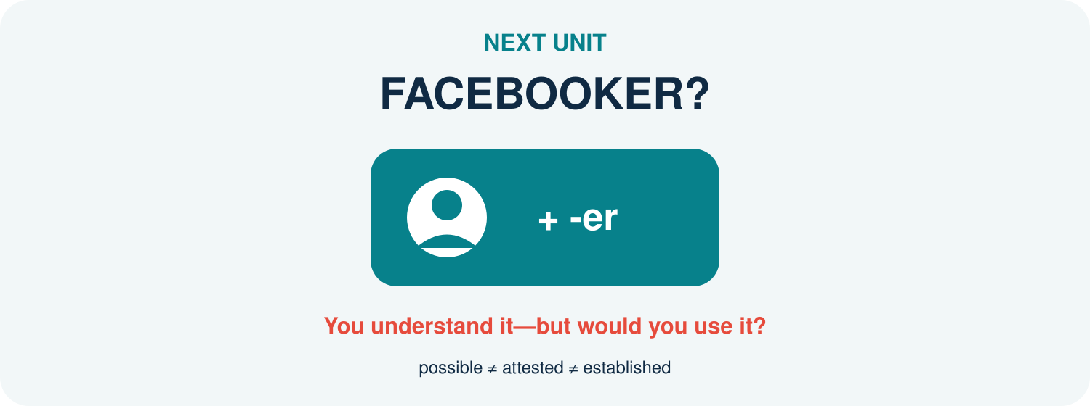
A formation can be structurally possible and understandable without being widely established.
Before accepting a new word, ask who uses it, where, and how often.

SOURCES USED IN THIS UNIT
Concepts and examples are pedagogical adaptations of the following sources:
Bauer, L., Lieber, R., & Plag, I. (2013). The Oxford reference guide to English morphology. Oxford University Press.
Lieber, R. (2021). Introducing morphology (3rd ed.). Cambridge University Press.
Plag, I. (2018). Word-formation in English (2nd ed.). Cambridge University Press.
UNIT 11
FACEBOOKER?
You understand it-but would you use it?
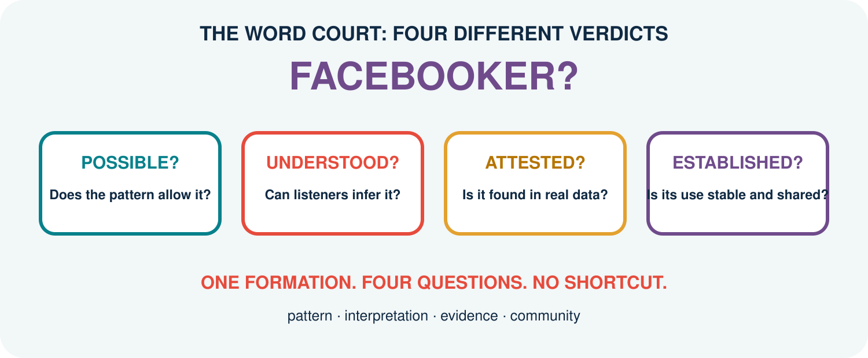
A possible word, an understood word, an attested word, and an established word are not the same thing.
ASK FOUR QUESTIONS BEFORE YOU PASS ONE VERDICT.

YOUR DISCOVERY PATH
In this unit, you will:
 NOTICE that structural well-formedness does not guarantee normal use.
 SEPARATE possible, interpretable, attested, and established formations.
 TEST productivity with controlled comparisons rather than isolated examples.
 EXPLAIN how constraints, competition, and blocking affect word formation.
 VERIFY a candidate with dictionary, corpus, and speaker evidence.
 ARGUE a Word Court case and revise the verdict when evidence changes.
1. PROPOSE | 2. CHALLENGE | 3. VERIFY | 4. REVISE
Build a candidate. | Test the pattern. | Collect evidence. | Update the verdict.

1. THE FIVE-SECOND VERDICT
React quickly: natural, understandable but unusual, or unclear?
A. YouTuber
B. TikToker
C. Facebooker
D. Instagrammer
E. podcaster
F. Zoomer
Q1. Which judgements were shared across the class? Which varied most?

Q2. Did understanding a formation automatically make it feel normal?

FIRST DISCOVERY: ACCEPTABILITY IS DATA, BUT A SINGLE SPEAKER’S FEELING IS NOT THE WHOLE CASE.

2. FOUR QUESTIONS, FOUR ANSWERS
A possible word conforms to the language’s structural resources. An interpretable formation can receive a meaning. An attested formation occurs in observable use. An established word has a relatively stable, shared place in community usage. These categories can overlap, but none logically guarantees the next (Bauer et al., 2013; Lieber, 2021).
Question | Evidence | Cautious answer
Can English build it? | base + pattern; constraints | possible / doubtful
Can people infer it? | speaker paraphrases | understood / unclear
Can we find it? | dated corpus or published examples | attested / unattested so far
Is it conventional? | spread, stability, range, dictionary evidence | established / emerging / limited
Q3. Why is ‘not found in my search’ weaker than ‘impossible’?

3. HOW PRODUCTIVE IS -ER?
Productivity is the availability of a morphological pattern for creating new words. It is gradient and constrained, not an unlimited licence to attach an affix to anything.
Base | Candidate | Likely interpretation | Initial judgement
teach | teacher | one who teaches | established
vlog | vlogger | one who vlogs | established
podcast | podcaster | one who podcasts/hosts | established
TikTok | TikToker | TikTok creator/user | established or emerging
Facebook | Facebooker | Facebook user/person linked to it | interpretable; status to test
library | libraryer | one linked to a library? | structurally doubtful/unusual
Q4. What properties of the base appear to favour an agent/person reading with -er?

4. ONE SUFFIX, SEVERAL RELATIONS
Do not reduce -er to the definition ‘a person who does X’. Compare the relation between base and referent.
TEACHER. a person who performs the action teach
LONDONER. a person associated with or living in London
SIX-FOOTER. a person or thing measuring six feet
TOASTER. an instrument that toasts
DINER. a person who dines; also a type of restaurant
FACEBOOKER. potentially a person associated with Facebook, but the exact relation needs context
Q5. Why does a broad relational meaning help explain Facebooker? Why does it also create ambiguity?

5. THE RIVAL ALREADY HAS THE JOB
A structurally possible formation may lose to an existing competitor. Blocking describes cases where an established form reduces the availability of another expected formation.
Intended meaning | Existing form | Predicted rival | Likely effect
person who steals | thief | stealer | competitor preferred
person who cooks | cook | cooker | cooker usually names an appliance
person from France | French person / Frenchman | Francer | rival unavailable
Facebook user | Facebook user | Facebooker | transparent phrase may compete
Q6. Does blocking mean that the rival can never occur? State the claim cautiously.

6. SEARCH RESULTS ARE NOT A VERDICT
A web hit may be a username, typo, quotation, non-English text, duplicate, or automatically generated page. A zero result may reflect corpus size or search design.
CHECK FORM. Search exact form, capitalisation variants, plural, and likely spelling variants.
CHECK CONTEXT. Read enough text to confirm meaning and grammatical use.
CHECK SOURCE. Prefer independent, dated, public examples from identifiable genres.
CHECK RANGE. Ask whether examples come from several writers, places, and dates.
CHECK COMPETITORS. Compare Facebooker with Facebook user, creator, member, or influencer.
Q7. Which check protects most directly against counting false positives?

RESEARCH ETHICS: Record public examples without exposing private profiles, messages, or unnecessary personal identifiers.

7. THE EVIDENCE LADDER
Rank claims by the strength of evidence available. Do not climb higher than the data allow.
Level | Claim | Minimum support | Facebooker status
1 | form is structurally analysable | base + -er analysis
2 | listeners can interpret it | independent paraphrases
3 | form is attested | verified contextual example(s)
4 | use is recurring | multiple independent sources
5 | form is established | stable spread + reference evidence
Q8. What is the highest level your current evidence safely supports?

8. MICRO-CORPUS CHALLENGE
Collect 10–20 public examples for one candidate and its strongest competitor. Use a spreadsheet or table.
Form | Date/genre | Meaning | Independent? | Keep?
Q9. After cleaning the data, which form has greater range? What can you not yet claim?

9. WORD COURT
Teams prosecute or defend a candidate: Facebooker, studygrammer, prompt engineer, Zoomer-or another agreed formation.
A. THE CHARGE: the claim under dispute:

B. STRUCTURE: base, affix/process, and constraints:

C. INTERPRETATION: two independent speaker paraphrases:

D. ATTESTATION: verified examples and search limits:

E. COMPETITION: stronger rival forms:

F. RANGE: genres, users, dates, and communities:

G. VERDICT: possible / understood / attested / emerging / established:

H. APPEAL: what new evidence could change the verdict?

COURT RULE: Every verdict must name its evidence and its limitation. ‘I have seen it’ and ‘I dislike it’ are not sufficient arguments.

10. CHECK YOUR UNDERSTANDING
A1. Distinguish possible, interpretable, attested, and established.

A2. What does productivity mean in morphology?

B1. Give two reasons why -er does not attach freely to every base.

B2. Explain blocking with one example.

C1. Why can raw web counts mislead morphological research?

C2. Design a cautious two-source verification plan for Facebooker.

D1. Evaluate: ‘If students understand a new word, it is already an English word.’

11. WHAT CAN YOU DO NOW?
CAN DO 1. I can separate four different claims about a candidate word.
CAN DO 2. I can treat productivity as gradient and constrained.
CAN DO 3. I can recognise competition and blocking.
CAN DO 4. I can clean attestations before counting them.
CAN DO 5. I can state the highest claim justified by my evidence.
CAN DO 6. I can argue and revise a Word Court verdict.

EXIT REFLECTION
R1. A judgement I revised after evidence was...

R2. The competitor I had overlooked was...

R3. The next formation I want to put on trial is...

12. NEXT UNIT
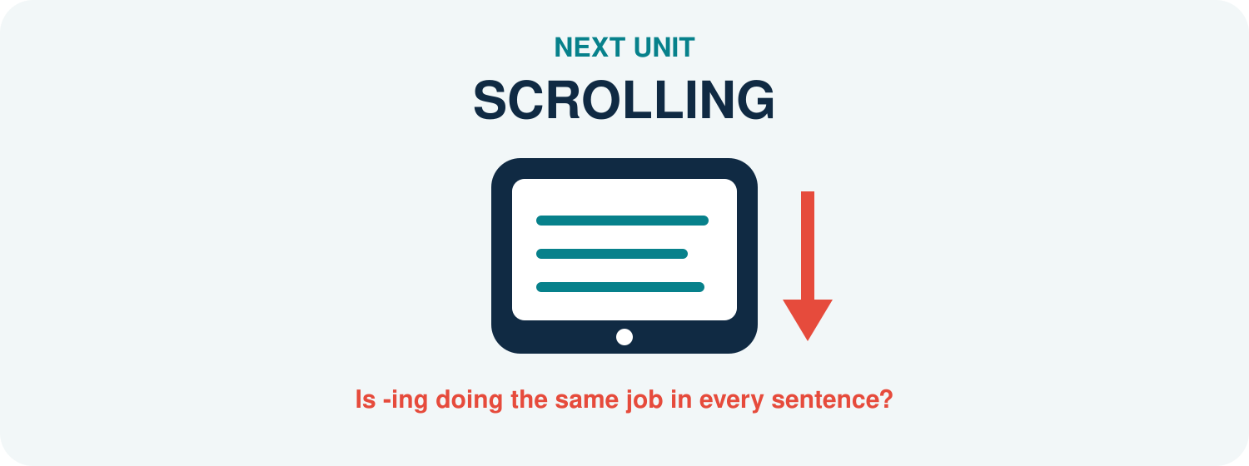
The same -ing form can participate in different constructions and grammatical functions.
Do not label -ing alone; read the whole sentence first.

SOURCES USED IN THIS UNIT
Concepts and examples are pedagogical adaptations of the following sources:
Bauer, L., Lieber, R., & Plag, I. (2013). The Oxford reference guide to English morphology. Oxford University Press.
Lieber, R. (2021). Introducing morphology (3rd ed.). Cambridge University Press.
Plag, I. (2018). Word-formation in English (2nd ed.). Cambridge University Press.
UNIT 12
SCROLLING
Is “scrolling” doing the same job in every sentence?
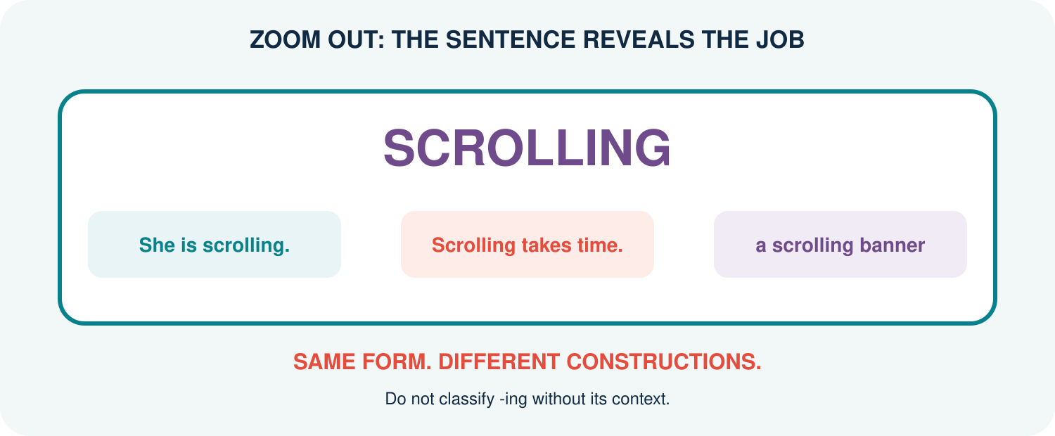
The visible -ing form remains constant while its construction and function change.
ZOOM OUT BEFORE YOU LABEL THE FORM.

YOUR DISCOVERY PATH
In this unit, you will:
 NOTICE that the string -ing does not identify one grammatical job by itself.
 ZOOM OUT from word form to phrase, clause, and sentence.
 TEST verb-like, noun-like, and adjective-like behaviour with diagnostics.
 DISTINGUISH morphological form, word class, construction, and grammatical function.
 EXPLAIN ambiguous or borderline cases without forcing premature labels.
 CREATE a Context Camera set that makes one -ing form perform several jobs.
1. SEE FORM | 2. ZOOM OUT | 3. TEST | 4. EXPLAIN
Locate -ing. | Read the whole unit. | Apply diagnostics. | State form and job.

1. ONE SCREEN, THREE JOBS
Compare the bold forms. First describe the surrounding structure; delay the labels.
A. Linh is scrolling through the comments.
B. Scrolling through comments takes time.
C. The scrolling banner covers the video.
D. Her scrolling annoyed the group.
Q1. Which form follows auxiliary be? Which heads the subject expression? Which modifies a noun?

Q2. Can spelling alone explain these different jobs?

FIRST DISCOVERY: MORPHOLOGICAL FORM IS ONE CLUE; SYNTACTIC CONTEXT REVEALS CATEGORY AND FUNCTION.

2. FOUR LEVELS-DO NOT MIX THEM
The suffix -ing forms an -ing word form from a verbal base. That form enters a larger phrase or clause, belongs to a grammatical category in that use, and performs a function in the sentence. Analyses and labels vary across grammatical traditions; this unit prioritises observable behaviour (Huddleston & Pullum, 2002; Bauer et al., 2013).
Level | Question | Example answer
Form | What visible morphology is present? | scroll + -ing
Category | What kind of head behaves here? | verb / noun / adjective
Construction | What larger unit contains it? | progressive VP / non-finite clause / modifier
Function | What job does that unit perform? | predicate / subject / object / modifier
Q3. Why can ‘subject’ not be the word class of scrolling?

3. PROGRESSIVE: BE + -ING
In a progressive construction, an -ing verb form combines with a form of be. Tense and agreement are normally carried by the auxiliary.
PRESENT. She is scrolling now.
PAST. She was scrolling during lunch.
QUESTION. Is she scrolling?
NEGATIVE. She is not scrolling.
Q4. Which word changes for tense or subject agreement? Which form stays as scrolling?

STRUCTURE: [is [scrolling through the comments]] - the -ing form remains verb-like and may take its complement.

4. VERB FORM, SUBJECT FUNCTION
An entire -ing clause can function as subject or complement while its head still behaves like a verb.
A. Scrolling quickly wastes time.
B. Scrolling through long feeds wastes time.
C. I enjoy scrolling quietly.
D. They stopped scrolling the page.
Q5. Which examples contain an adverb modifying scrolling? Which contain a complement after it?

Q6. Why does subject function in A–B not automatically make scrolling a noun?

ANALYSIS ADOPTED HERE: scrolling heads a non-finite -ing clause; the whole clause, not the suffix alone, performs subject or complement function.

5. MODIFYING A NOUN
An -ing form may occur before or after a noun and describe an ongoing activity or characteristic.
A. a scrolling banner
B. students scrolling in the hallway
C. the rapidly scrolling text
D. an annoying notification
Q7. Which forms still allow a verbal complement or adverb? Which item behaves more like an established adjective?

CAREFUL: ‘Before a noun’ does not prove adjective status. Participial clauses can modify nouns, and some -ing forms become lexical adjectives.

6. WHEN -ING IS INSIDE A NOUN
Some -ing formations behave as ordinary nouns. Compare their noun diagnostics with verb-headed clauses.
Expression | Plural? | Adjective/determiner? | Object or of-phrase?
two paintings | yes | beautiful paintings | paintings of the city
the building | buildings | old building | building of stone
her constant scrolling | usually mass-like | constant scrolling | scrolling through feeds / of the text
scrolling the feed | no noun plural | quickly, not *constant* in same role | direct object the feed
Q8. Which properties distinguish prototypical nouns from verb-headed -ing clauses?

7. THE DIAGNOSTIC DASHBOARD
Use several diagnostics. One test may fail or give a borderline result.
Diagnostic | More verb-like | More noun-like | More adjective-like
Complements | direct object / PP | of-phrase | selected complement limited
Modifiers | adverb: quickly | adjective: constant | degree adverb: very (when possible)
Inflection frame | be + -ing | plural/determiner | comparative/very for some adjectives
Sentence role | heads clause | heads NP | heads AdjP or modifies noun
Q9. Why should category decisions be based on converging evidence?

8. CONTEXT RESCUE
The isolated form hides too much. Expand each fragment until one analysis becomes testable.
Fragment | Expanded context | Category of -ing head | Function of larger unit
scrolling
building
painting
interesting
streaming
Q10. Which fragment allowed the greatest range of analyses?

9. CONTEXT CAMERA STUDIO
Choose one student-life base: scroll, stream, study, message, game, or another suitable verb.
FRAME 1. Progressive sentence with be + -ing:

FRAME 2. -ing clause functioning as subject:

FRAME 3. -ing clause functioning as complement:

FRAME 4. -ing unit modifying a noun:

FRAME 5. A clearly noun-like or adjective-like use, if available:

TEST. Diagnostics supporting each analysis:

COMPARE. What stayed constant and what changed?

LIMIT. One example that remains uncertain:

STUDIO RULE: Every label must point to evidence outside the letters -ing. If evidence conflicts, report the conflict.

10. CHECK YOUR UNDERSTANDING
A1. Distinguish form, category, construction, and function.

A2. How is progressive -ing identified?

B1. Why can an -ing clause function as subject while remaining verb-headed?

B2. Give two diagnostics for verb-like behaviour.

C1. Contrast quickly scrolling the feed with constant scrolling of the feed.

C2. Why is position before a noun insufficient evidence for adjective status?

D1. Evaluate: ‘Every -ing word used as a subject is a gerund noun.’

11. WHAT CAN YOU DO NOW?
CAN DO 1. I can separate -ing form from its category and function.
CAN DO 2. I can identify the progressive construction.
CAN DO 3. I can recognise verb-headed -ing clauses in subject/complement roles.
CAN DO 4. I can compare verb-like, noun-like, and adjective-like diagnostics.
CAN DO 5. I can expand isolated forms into testable contexts.
CAN DO 6. I can report uncertainty instead of forcing a label.

EXIT REFLECTION
R1. The label I used too quickly before was...

R2. The strongest diagnostic today was...

R3. One -ing form I now want to film with the Context Camera is...

12. NEXT UNIT
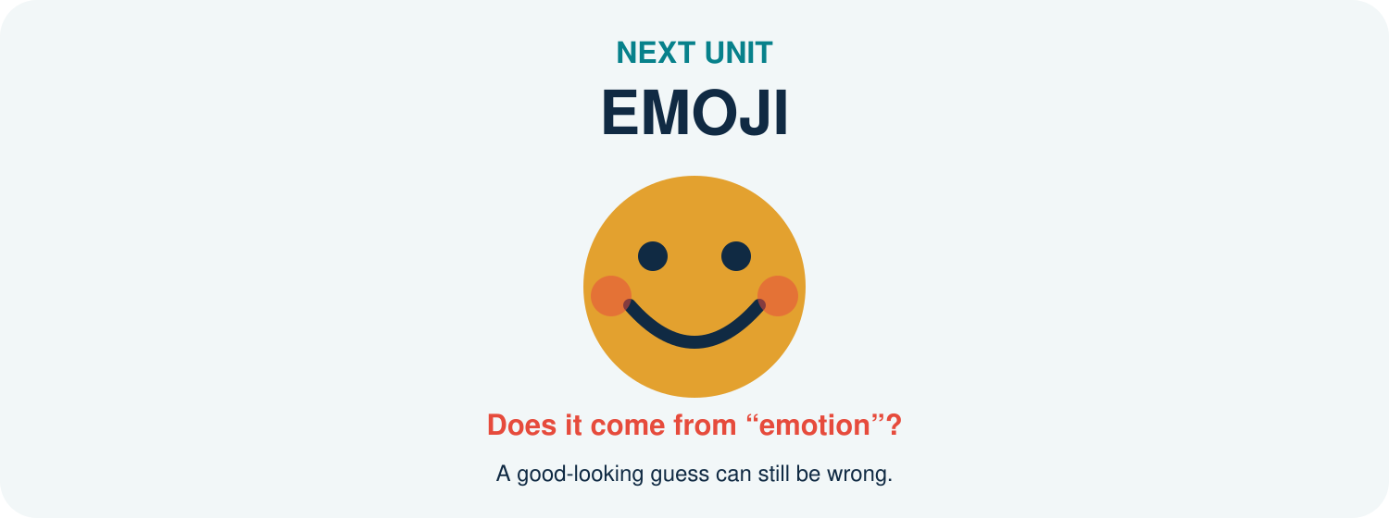
A familiar-looking resemblance may invite a false etymological analysis.
A good hypothesis is only the beginning: verify the history.

SOURCES USED IN THIS UNIT
Concepts and examples are pedagogical adaptations of the following sources:
Bauer, L., Lieber, R., & Plag, I. (2013). The Oxford reference guide to English morphology. Oxford University Press.
Huddleston, R., & Pullum, G. K. (2002). The Cambridge grammar of the English language. Cambridge University Press.
Lieber, R. (2021). Introducing morphology (3rd ed.). Cambridge University Press.
UNIT 13
EMOJI
Does it come from “emotion”?
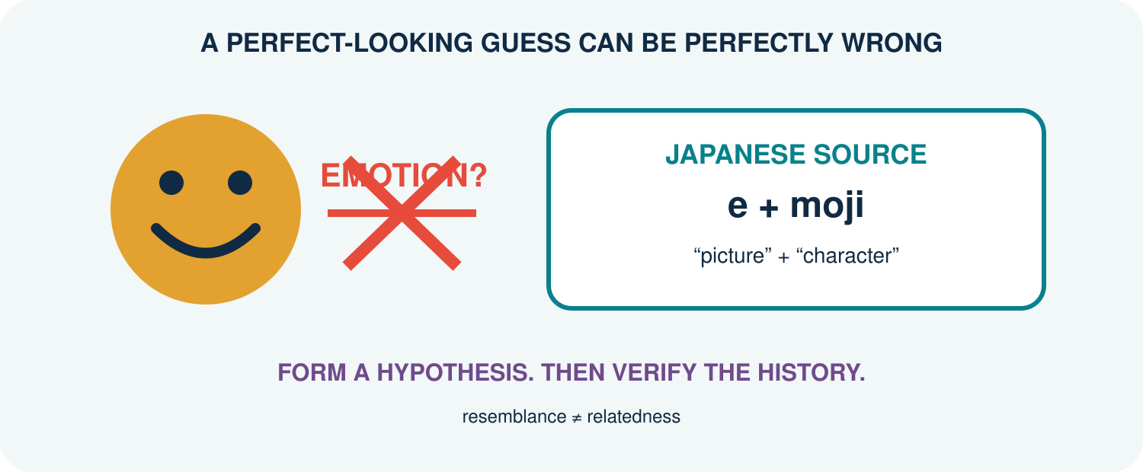
Emoji resembles emotion in English, but resemblance does not establish historical relatedness.
HYPOTHESISE BRAVELY. VERIFY RUTHLESSLY.

YOUR DISCOVERY PATH
In this unit, you will:
 NOTICE how familiar spelling can trigger a convincing false etymology.
 SEPARATE synchronic analysis from diachronic history.
 TRACE emoji from Japanese source material into English usage.
 COMPARE borrowing, adaptation, semantic extension, and folk reanalysis.
 VERIFY an etymological claim with independent reference evidence.
 BUILD an Etymology Case File that records both findings and uncertainty.
1. GUESS | 2. TRACE | 3. VERIFY | 4. REPORT
Form a hypothesis. | Map the pathway. | Check sources. | State confidence.

1. THE BEAUTIFUL WRONG ANSWER
Complete the guess before opening a dictionary.
emoji = emotion + __________ ?
Q1. Why does emotion feel like a plausible source? List only form- and meaning-based clues.

Q2. What historical evidence would be needed before accepting the guess?

REVEAL: English emoji was borrowed from Japanese. Its source is associated with Japanese e ‘picture’ + moji ‘character’; it is not historically built from English emotion (Merriam-Webster, n.d.).

2. TWO QUESTIONS, TWO CLOCKS
Synchronic morphology asks how a word is structured and related to other forms in a language at a particular time. Diachronic analysis asks how the word arose and changed through time. A current resemblance may influence speakers without revealing the true historical source (Bauer et al., 2013; Lieber, 2021).
Question | Synchronic answer | Diachronic answer
Can English speakers connect emoji with emotion? | possibly, by resemblance | not evidence of origin
Is e- an English prefix here? | no productive analysis established | Japanese source element
Does English allow emojis? | yes: English plural inflection | plural developed after borrowing
Q3. Why can a historically complex source become synchronically simple for English speakers?

3. THE BORROWING PATHWAY
Borrowing brings a lexical item from one language into another. The receiving language may adapt its pronunciation, spelling, meaning, and grammar.
SOURCE LANGUAGE. Japanese supplies the item emoji.
TRANSFER. The form enters English through contact and digital technology.
PHONOLOGICAL ADAPTATION. English speakers pronounce it using English sound patterns and accents.
MORPHOLOGICAL INTEGRATION. English adds ordinary morphology: emoji → emojis.
SEMANTIC DEVELOPMENT. Usage broadens across platforms, genres, and communicative practices.
Q4. Which stage shows most clearly that emoji now participates in English morphology?

4. THE FALSE-FRIEND MIRROR
Accidental resemblance can produce folk etymology or reanalysis: speakers reshape or reinterpret an unfamiliar form through familiar material.
Claim | Why tempting? | How to test | Current verdict
emoji ← emotion | form + digital feelings | historical dictionaries | false origin
hamburger ← ham + burger | modern segmentation | trace Hamburg + -er | historically misleading
bridegroom ← bride + groom | familiar groom | older forms/history | folk reshaping
island contains land | visible spelling | earlier forms | s is historically intrusive
Q5. What is the difference between a useful synchronic association and a true etymology?

5. AVATAR CHANGES WORLDS
Borrowed words may undergo semantic extension after entering new domains.
EARLIER SOURCE. Sanskrit avatāra is associated with descent or incarnation, especially divine embodiment.
ENGLISH RELIGIOUS/CULTURAL USE. avatar refers to an incarnation or embodiment.
DIGITAL EXTENSION. avatar comes to denote a user’s graphical or virtual representation.
CURRENT NETWORK. profile picture, game character, virtual self, embodiment-and branded uses coexist.
Q6. Which conceptual link connects embodiment with digital representation?

Q7. Does a new digital sense erase the earlier sense?

6. ONE LOAN, ENGLISH GRAMMAR
Once borrowed, a form can enter English word families and constructions.
Borrowed base | English form | Process | Evidence of integration
emoji | emojis; also plural emoji | overt -s plural; zero-marked plural variant | English number contrast and accepted variation
avatar | avatars | plural inflection | English number contrast
karaoke | karaoke night | compounding/modification | new English combination
robot | robotic / robotics | derivation | English-family expansion
emoji | emoji-like | suffixation/combining pattern | new comparison
Q8. Why should present-day English morphology analyse these forms even when their bases were borrowed?

7. HASHTAG: HISTORY MEETS STRUCTURE
Hashtag is synchronically transparent to many English speakers: hash + tag. Its current digital meaning depends on a technological practice and community convention.
VISIBLE STRUCTURE. hash + tag
EARLIER MATERIAL. hash names the # symbol; tag names a label or marker.
DIGITAL CONVENTION. a # plus a string labels, indexes, or organises posts.
FAMILY GROWTH. hashtag, hashtags, hashtagged, hashtagging; hashtag can also function as a verb.
Q9. Which facts are structural, which are historical, and which are usage-based?

8. SOURCE TRIANGULATION
Never trust one attractive webpage. Compare at least two independent, reputable sources.
Candidate | Source language | Earlier form/meaning | English pathway | Confidence
emoji
avatar
karaoke
robot
hashtag
Q10. Where do your sources disagree or differ in detail? Record the difference instead of hiding it.

9. ETYMOLOGY CASE FILE
Choose a word from student life whose history may be surprising.
CASE. Word, current meaning, and context sentence:

HYPOTHESIS. My initial guess and why it looked plausible:

SOURCE 1. Reference, historical claim, and evidence:

SOURCE 2. Independent reference and comparison:

PATHWAY. Source language → intermediate stage(s) → English:

ADAPTATION. Changes in form, pronunciation, grammar, or meaning:

SYNCHRONY. How English speakers may analyse it now:

VERDICT. Supported / rejected / uncertain, with confidence level:

DETECTIVE RULE: Report what the evidence supports-not the most entertaining story. Cite every historical claim.

10. CHECK YOUR UNDERSTANDING
A1. Distinguish synchronic analysis from diachronic analysis.

A2. Why is emoji not historically related to English emotion?

B1. Name three ways a loanword can be adapted.

B2. How does emojis demonstrate morphological integration?

C1. Explain semantic extension using avatar.

C2. Why is source triangulation necessary?

D1. Evaluate: ‘If two words look and mean something similar, they must be historically related.’

11. WHAT CAN YOU DO NOW?
CAN DO 1. I can distinguish resemblance from historical relatedness.
CAN DO 2. I can separate synchronic structure from diachronic origin.
CAN DO 3. I can trace a basic borrowing pathway.
CAN DO 4. I can identify grammatical and semantic adaptation.
CAN DO 5. I can triangulate an etymological claim.
CAN DO 6. I can write an evidence-based case file with uncertainty.

EXIT REFLECTION
R1. The beautiful wrong answer I almost accepted was...

R2. The source detail that changed my mind was...

R3. The next word I want to investigate is...

12. NEXT UNIT
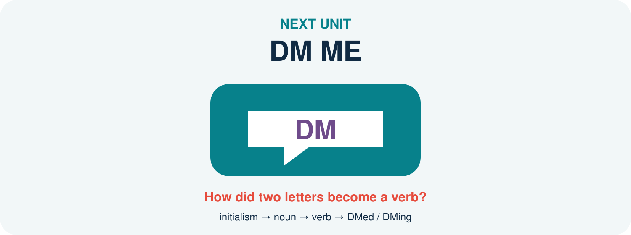
Two initial letters become a noun, then a verb, and then accept English inflection.
Follow the pathway from abbreviation to full grammatical participation.

SOURCES USED IN THIS UNIT
Concepts and examples are pedagogical adaptations of the following sources:
Bauer, L., Lieber, R., & Plag, I. (2013). The Oxford reference guide to English morphology. Oxford University Press.
Lieber, R. (2021). Introducing morphology (3rd ed.). Cambridge University Press.
Merriam-Webster. (n.d.). Emoji. In Merriam-Webster.com dictionary. Retrieved July 16, 2026, from https://www.merriam-webster.com/dictionary/emoji
Oxford English Dictionary. (n.d.). Emoji, n. In OED online. Oxford University Press.
UNIT 14
DM ME
How did two letters become a verb?
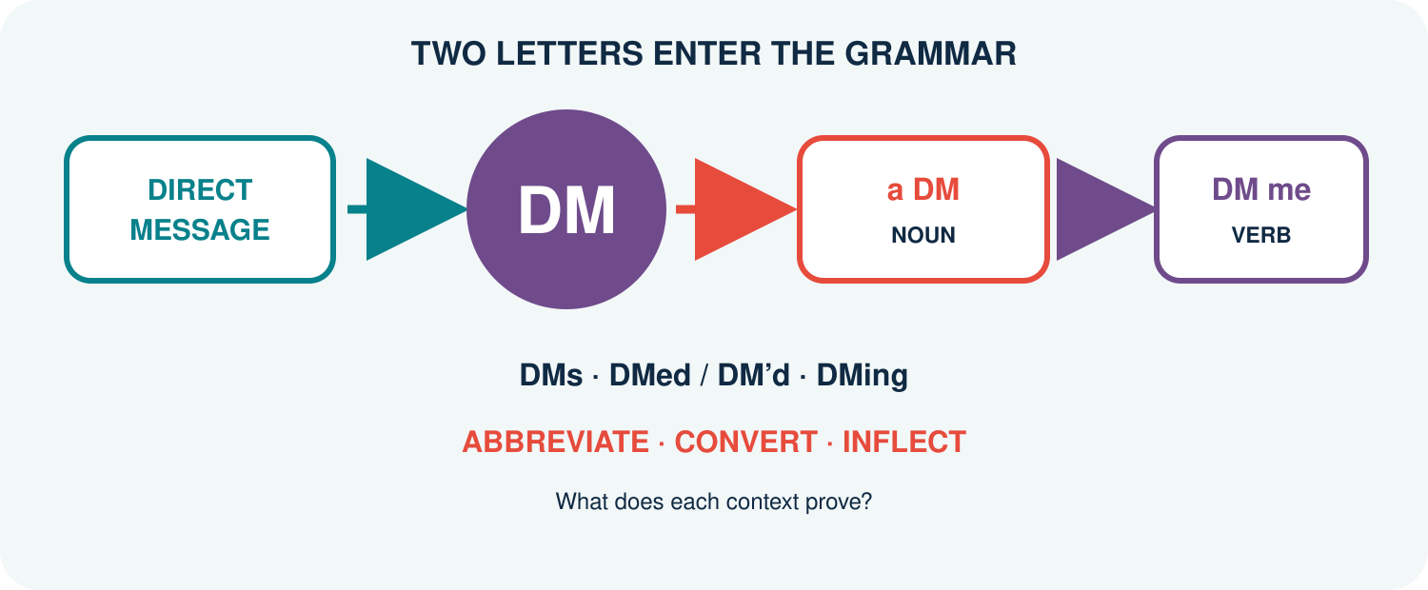
An initialism can become a lexical base, shift category, and accept ordinary English inflection.
FOLLOW THE EVIDENCE FROM ABBREVIATION TO GRAMMAR.

YOUR DISCOVERY PATH
In this unit, you will:
 NOTICE that DM behaves as more than a shortened spelling.
 TRACE direct message → DM → noun DM → verb DM.
 DISTINGUISH initialism, conversion, and inflection in one pathway.
 SEARCH dictionary entries and corpus concordance lines strategically.
 COMPARE DMs, DMed, DM’d, and DMing as competing written variants.
 BUILD a reproducible Evidence Trail from query to cautious conclusion.
1. QUERY | 2. CLEAN | 3. CLASSIFY | 4. CLAIM
Search variants. | Remove noise. | Code the contexts. | Limit the conclusion.

1. OPEN THE MESSAGE
Read the mini-chat. Underline every form related to direct message.
A. Send me a DM after class.
B. I DM my group every Friday.
C. She DMed me yesterday.
D. They are DMing the organiser now.
E. Three DMs arrived during the meeting.
Q1. Which forms are nouns? Which are verbs? What context proves each decision?

Q2. Which examples show number, tense, or progressive grammar?

FIRST DISCOVERY: LETTERS BECOME LINGUISTIC DATA ONLY IN CONTEXT.

2. THE PATHWAY HAS THREE STEPS
An initialism is formed from initial letters pronounced separately. Conversion allows a form to enter a new lexical category without an overt derivational affix. Inflection then supplies grammatical contrasts such as number or tense (Bauer et al., 2013; Lieber, 2021).
ABBREVIATION. direct message → DM; speakers pronounce the letters separately.
CONVERSION. a DM (noun) → to DM (verb), with no visible derivational affix.
INFLECTION. DM → DMs; DM → DMed/DM’d; DM → DMing.
WORKING MAP: direct message → DMₙ → DMᵥ → DMed / DMing
Q3. Why should DMed not be analysed as part of the original initialism?

3. NOUN OR VERB? LET THE FRAME DECIDE
Classify DM from distribution, not from capital letters.
Context clue | Noun frame | Verb frame | Example
Determiner/number | a DM; three DMs | - | I received a DM.
Subject + tense | - | I DM; she DMs | She DMs daily.
Auxiliary | - | will DM; is DMing | I will DM you.
Object/complement | send/read a DM | DM a person/message | DM me the file.
Q4. What evidence in DM me rules out noun DM in that sentence?

4. SPELLING HAS NOT SETTLED
Newly integrated forms often show orthographic variation. Treat variants as data rather than immediate errors.
Variant | Morphology | Reader advantage | Possible problem
DMed | DM + -ed | compact; regular-looking | capital boundary may look unusual
DM’d | DM + ’d | boundary visible | apostrophe conventions vary
DM-ed | DM + -ed | boundary highly visible | hyphen may feel marked
DMing | DM + -ing | common compact pattern | readers must recover base
DM-ing | DM + -ing | boundary visible | less conventional
Q5. Which variant would you search first? Which variants must be added to avoid missing data?

5. DICTIONARY: MAP, NOT TERRITORY
A dictionary may record pronunciation, category, meanings, dates, labels, and variants. It cannot show every current context or settle all community variation.
HEADWORD. Check DM and lower-case/capitalisation variants.
CATEGORY. Does the entry list noun, verb, or both?
SENSE. Does DM mean direct message, send a direct message, or another expansion?
INFLECTION. Does the entry show DMed, DM’d, DMing, or other forms?
DATE/LABEL. What is the earliest evidence and is the use labelled informal?
Q6. What can a corpus contribute that a dictionary entry may not?

6. CORPUS: READ THE LINES
A concordance places the search item in repeated contexts. The researcher must still inspect, classify, and document decisions.
Line | Left context | Node | Right context | Code
1 | send me a | DM | when you arrive | N.SG
2 | she | DMs | the link to us | V.PRS
3 | two unread | DMs | were waiting | N.PL
4 | he | DMed | the organiser | V.PST
5 | they are | DMing | each other | V.PROG
Q7. Which words outside DM provide the strongest category evidence in each line?

7. QUERY DESIGN BEFORE COUNTING
Write the search plan before seeing the results. This reduces selective searching after a preferred answer appears.
TARGETS. DM, DMs, DMed, DM’d, DMing, and justified variants.
EXCLUSIONS. Initials of names, company codes, units, quotations, duplicates, and unrelated expansions.
FIELDS. form, lemma, category, tense/number, meaning, date, genre, source, notes.
WINDOW. Read enough left and right context to justify the code.
AUDIT. Keep excluded lines and reasons in a separate log.
Q8. Why is a pre-written exclusion rule better than deleting inconvenient examples later?

8. FREQUENCY NEEDS A DENOMINATOR
Raw counts depend on corpus size. Normalised frequency makes corpora or periods more comparable.
NORMALISED FREQUENCY = (target tokens ÷ total corpus tokens) × 1,000,000
Subcorpus | DM verb tokens | All tokens | Per million
A | 24 | 2,000,000
B | 40 | 10,000,000
C | 6 | 500,000
Q9. Calculate the rates. Which subcorpus has the highest relative frequency?

CAREFUL: FREQUENCY DOES NOT BY ITSELF EXPLAIN ACCEPTABILITY, PRODUCTIVITY, OR CAUSE.

9. DM EVIDENCE TRAIL
Conduct a small, reproducible investigation of DM or another agreed digital initialism.
QUESTION. My precise research question:

SOURCES. Dictionary and corpus, with access details:

QUERIES. Exact forms, variants, and filters:

RULES. Inclusion and exclusion criteria written in advance:

SAMPLE. Number of lines inspected and retained:

CODING. Category, meaning, and inflection fields:

RESULT. Counts and normalised frequencies where appropriate:

CLAIM. What the evidence supports-and does not support:

REPLICATION. What another student needs to repeat the search:

DATA ETHICS: Use public corpus data, minimise personal details, quote only what analysis requires, and follow the source’s terms of use.

10. CHECK YOUR UNDERSTANDING
A1. Distinguish initialism, conversion, and inflection in the DM pathway.

A2. What proves noun or verb status in context?

B1. Why should several spelling variants be searched?

B2. What is a concordance line?

C1. Calculate 18 tokens in a 3-million-word subcorpus per million words.

C2. Give two reasons to retain an exclusion log.

D1. Evaluate: ‘The most frequent spelling is the only correct morphological form.’

11. WHAT CAN YOU DO NOW?
CAN DO 1. I can trace an initialism through conversion and inflection.
CAN DO 2. I can diagnose noun and verb DM from context.
CAN DO 3. I can design searches that include spelling variation.
CAN DO 4. I can code and clean concordance lines.
CAN DO 5. I can calculate normalised frequency.
CAN DO 6. I can write a reproducible Evidence Trail with limited claims.

EXIT REFLECTION
R1. The context clue that helped most was...

R2. A false positive I would now remove is...

R3. The digital initialism I want to investigate next is...

12. NEXT UNIT

The course now turns from analysing existing formations to designing, testing, and revising a new one.
Creativity becomes scholarship when the evidence can change the design.

SOURCES USED IN THIS UNIT
Concepts and examples are pedagogical adaptations of the following sources:
Bauer, L., Lieber, R., & Plag, I. (2013). The Oxford reference guide to English morphology. Oxford University Press.
Davies, M. (2008–). The Corpus of Contemporary American English (COCA). https://www.english-corpora.org/coca/
Lieber, R. (2021). Introducing morphology (3rd ed.). Cambridge University Press.
Merriam-Webster. (n.d.). DM. In Merriam-Webster.com dictionary. Retrieved July 16, 2026, from https://www.merriam-webster.com/dictionary/DM
UNIT 15
THE NEXT WORD
Could it begin with you?
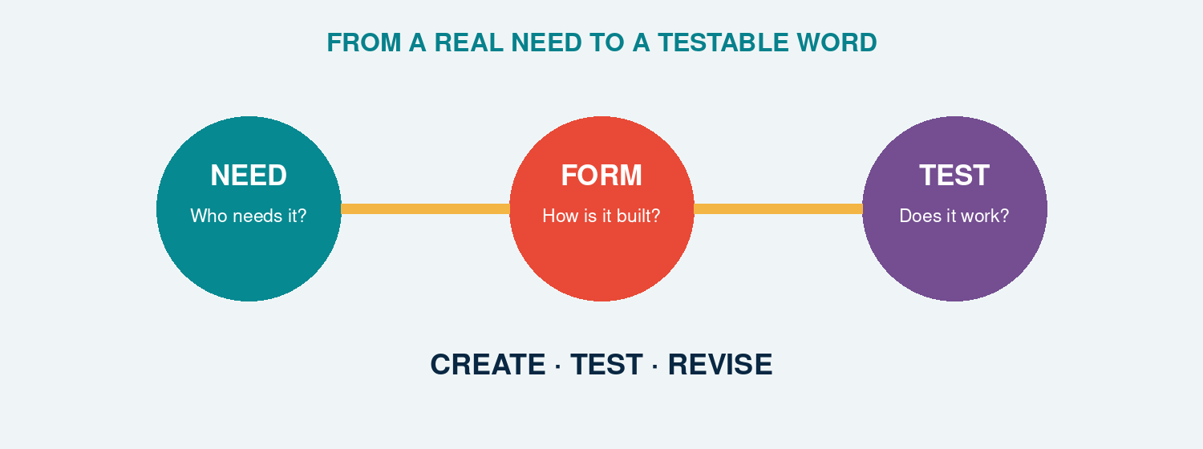
A new formation becomes valuable when structure, meaning, evidence, and audience meet.
CREATE BRAVELY. TEST HONESTLY. REVISE INTELLIGENTLY.

YOUR DISCOVERY PATH
In this unit, you will:
 RECONNECT ideas from all fourteen earlier units.
 DESIGN a new English formation for a real communicative need.
 PREDICT its structure, meaning, pronunciation, and grammatical behaviour.
 TEST whether other users understand and accept it.
 VERIFY claims with dictionaries and corpus evidence.
 REVISE the formation and defend a final version.

1. THE MISSING LABEL
Think of an experience in student life, online culture, learning, work, or community that English does not name efficiently for your group.
SITUATION. What repeatedly happens?

PEOPLE. Who needs the word?

GAP. Why are existing expressions too long, vague, or unsuitable?

CONTEXT. Where would the word naturally appear?

A clever form without a communicative need is only a puzzle. Begin with people and use.

2. YOUR MORPHOLOGICAL TOOLBOX
DERIVATION. Add a prefix or suffix: creator, unstoppable.
INFLECTION. Place the word in a paradigm: TikToker/TikTokers.
COMPOUNDING. Combine bases: blackbird, bookworm.
BLENDING/CLIPPING. Compress source material: vlog.
CONVERSION. Change category without a visible affix: to DM.
BORROWING. Adapt material from another language: emoji.
SEMANTIC EXTENSION. Give an established form a related new use.
Q1. Which process best fits your communicative gap? Why?

Q2. What alternative process could create a competing candidate?

3. THREE CANDIDATES
Create three forms, not one. Variation makes design decisions visible.
CANDIDATE A. Form · process · intended meaning · example sentence:

CANDIDATE B. Form · process · intended meaning · example sentence:

CANDIDATE C. Form · process · intended meaning · example sentence:

4. STRUCTURE BEFORE STYLE
For each candidate, supply an analysis that another morphology student can challenge.
Test | Candidate A | Candidate B | Candidate C
Segmentation
Root/base/stem
Process and order
Word class
Meaning contribution
Expected inflection
Pronunciation issue
Q3. Which analysis requires the fewest unsupported assumptions?

5. THE COUNTEREXAMPLE ATTACK
Ask a partner to break your analysis.
SPELLING ATTACK. Could the apparent pieces be accidental?

MEANING ATTACK. Does the whole mean what the parts predict?

ORDER ATTACK. Could the affixes combine in another hierarchy?

GRAMMAR ATTACK. Can the form behave in a real sentence?

6. THE AUDIENCE TEST
Test meaning before explaining the word. Use at least five participants outside your design group.
User | Context shown | Meaning guessed | Class guessed | Would use? | Comment
1
2
3
4
5
Q4. How many users understood the intended core meaning without help?

Q5. Which misunderstanding reveals a structural or semantic weakness?

7. ETHICS OF SMALL DATA
Ask consent, avoid collecting sensitive identifiers, report the number and type of participants, and do not present a classroom convenience sample as evidence about all English users.

8. DICTIONARY + CORPUS CHECK
A candidate may already exist. Search before claiming invention.
DICTIONARY. Headword found? Meaning and date:

CORPUS. Search string, corpus, frequency, and date:

CONCORDANCE. Three authentic contexts:

VARIANTS. Competing spellings or forms:

VERDICT. Apparently new / rare / established / uncertain:

LIMITATION. What your search cannot prove:

EVIDENCE RULE: ‘I DID NOT FIND IT’ IS NOT THE SAME AS ‘IT HAS NEVER EXISTED.’ REPORT SOURCES, SEARCHES, AND LIMITS.

9. PRODUCTIVITY CHECK
If your candidate uses a pattern, test whether that pattern accepts other suitable bases and what restrictions it has.
Q6. What established forms support your pattern?

Q7. What blocked, awkward, or impossible forms reveal its constraints?

10. REVISION STUDIO
VERSION 1. Original candidate and analysis:

EVIDENCE. Most important audience or corpus finding:

DECISION. Keep / modify / reject-with reason:

VERSION 2. Revised form, meaning, and example:

TRADE-OFF. What improved, and what became less elegant?

FINAL CLAIM. What can you responsibly claim about the formation?

11. THE ONE-MINUTE DEFENCE
Present the need, formation, structure, evidence, revision, and limitation in sixty seconds. Your audience votes: CLEAR · INTERESTING · USABLE · NEEDS WORK.

12. CHECK YOUR UNDERSTANDING
A1. Explain why a possible word is not automatically an established word.

A2. Distinguish structural well-formedness from audience acceptance.

B1. Give two kinds of evidence relevant to a new formation.

B2. Why should a creator search dictionaries and corpora before claiming novelty?

C1. Explain how a failed candidate can still demonstrate morphological learning.

C2. Evaluate: ‘If everyone in my group understands it, English has accepted it.’

13. WHAT CAN YOU DO NOW?
CAN DO 1. I can identify a communicative lexical gap.
CAN DO 2. I can select and justify a word-formation process.
CAN DO 3. I can analyse structure, meaning, category, and inflection.
CAN DO 4. I can test a candidate with users and reference data.
CAN DO 5. I can report uncertainty and limitations.
CAN DO 6. I can revise and defend an evidence-based formation.

14. THE NEXT WORD

Morphological creativity links a form to a need, a structure, an interpretation, and a community of users.
Your word does not need to conquer the internet. It needs to make a thoughtful, testable contribution-and teach you something when it fails.

SOURCES USED IN THIS UNIT
Concepts and examples are pedagogical adaptations of the following sources:
Bauer, L., Lieber, R., & Plag, I. (2013). The Oxford reference guide to English morphology. Oxford University Press.
Carstairs-McCarthy, A. (2002). An introduction to English morphology: Words and their structure. Edinburgh University Press.
Lieber, R. (2021). Introducing morphology (3rd ed.). Cambridge University Press.

APPENDIX A - SUGGESTED ANSWERS
These answers support analysis rather than replace it. Where pronunciation, context, evidence, or theoretical framework permits more than one analysis, the relevant qualification is stated explicitly.
UNIT 1 - TIKTOKERS
These are suggested answers, not scripts that students must copy. Open questions may have several reasonable answers when the criterion and evidence are clear.

SECTION 1 - YOUR DIGITAL NAME
A–D. Answers will vary. A strong response explains the intended identity, identifies familiar material in the username, and considers whether another speaker has enough information to understand it. Students should not be required to share a real account.

SECTION 2 - FIRST LOOK
TikTok. The full platform name; no added ending in this comparison; it refers to the platform.
TikToker. TikTok stays; -er is added; it refers to one person connected with TikTok.
TikTokers. TikToker stays; final -s is added; it refers to more than one TikToker.
Q1–Q3. TikTok; TikToker; TikTokers.
Q4. No. In this data, -er helps form a word referring to a person, while -s adds plural information. Formal terminology is not required yet.

SECTIONS 3–5 - PATTERNS AND WORKING IDEAS
3A. -er
3B. -s
Q5. -er
Q6. -s
Q7. The final consonant letter g is doubled: blog → blogger.
H1. Sample: -er appears to help create a word referring to a person connected with the starting form.
H2. Sample: final -s appears to express more than one.
Q8. Yes, all five end with the letters er.
Q9. No. Similar letters do not automatically have the same morphological job.
Q10. No. Teacher has a clear relationship with teach in this data. Corner is not regularly interpreted as ‘a person or thing connected with the action corn’ in the same pattern.

SECTION 6 - WHICH ONE DOES NOT BELONG?
Possible answer 1. Black bird, because it contains a visible space and functions as a phrase in the intended comparison.
Possible answer 2. TikTokers, because it is the only plural expression in the set.
Possible answer 3. Unstoppable, because it begins with an added form in this set and is not a person/platform expression or a two-word/compound comparison.
Possible answer 4. Greenhouse, because its conventional whole-word meaning is not simply ‘a house that is green’. Other answers are possible with a clear criterion.

SECTIONS 7–10 - MORPHOLOGY, ANALYSIS AND CREATION
Q11. Answers will vary. The explanation should connect the chosen question to the student's curiosity.
YOUTUBERS - Form. YouTube + a form written -er, followed by final -s; capitalisation is retained from the platform name in the usual spelling.
YOUTUBERS - Meaning. More than one YouTuber; in ordinary current use, a YouTuber is a person who creates or posts video content on YouTube. Broader context-dependent uses should be justified with evidence.
YOUTUBERS - Function. -er helps form the person-denoting word; final -s expresses plurality in the target contexts.
Living Word Collection. Answers will vary. A useful entry includes the expression, a source or context, and a genuine question or observation.
Word Lab. Answers will vary. Evaluate whether the intended meaning is recoverable, whether the proposed pattern is recognisable, and whether peer feedback distinguishes understandable from natural.

SECTION 11 - CHECK YOUR UNDERSTANDING
A1. YouTube is the starting platform name; YouTuber refers to one person; YouTubers refers to more than one. The visible additions are -er and then -s.
A2. Stream → streamer adds -er; streamer → streamers adds final -s.
B1. In the selected data, -er helps create a person-denoting word from a starting form such as TikTok, YouTube, stream, game or blog.
B2. Final -s can give plural information: more than one person or item in the target noun contexts.
C1. Because the same letters may occur accidentally. We need evidence from meaning, function, word relationships and use, not spelling alone.
D1–D3. Answers will vary. Credit a cautious hypothesis that states what is observed, what contribution is proposed, and what remains uncertain.

UNIT 2 - RESEARCHER
Suggested answers guide discussion; they are not scripts that students must copy.
1A–C. Answers vary. A strong initial answer treats a split as a hypothesis and asks for related forms, meaning, function, and use.
Q1–Q3. Research remains stable; -er is associated with a person; -s, -ing, and -ed provide grammatical information in the target examples.
Q4. A defensible first analysis is research + -er. Research is the base/root in this word family; -er contributes a person-related function.
Q5. Researcher: root/base research; suffix -er.
Q6. Yes: They research language change.
Q7. No. Person-forming -er is bound in present-day English.
Q8. Rewrite, replay, and reheat clearly support the meaning ‘again’; context can refine the interpretation.
Q9. No. Present-day research is not normally understood compositionally as ‘search again’.
Q10. The analysis research + -er is strong: both parts are identifiable; -er has a regular person-forming contribution; related words support the contrast.
A1. A morpheme is a minimal unit of morphological form with a regular contribution to meaning or grammatical function.
A2. The same letters may occur accidentally or historically without functioning as the same morpheme in present-day English.
B1–B2. Teach is the root and a free morpheme; -er is a suffix and a bound morpheme.
C1. Because re- in present-day research does not transparently make the regular ‘again’ contribution found in rewrite or replay.
D1. Answers vary. Credit analyses that present evidence and clearly mark uncertainty.

UNIT 3 - DREAMERS
Q1–Q2. Dream recurs with related lexical content. Its role must be stated relative to each operation.
Q3. Dreamer contains the root dream plus -er; the larger form dreamer is the stem selected by plural -s.
Q4. Yes. Daydream is internally complex but serves as the base for -er.
Q5. Base includes any input to a morphological process; roots and stems are more specific relational notions.
Q6. Answers vary. Credit analyses using process, category, meaning, and distribution.
Q7–Q8. Dream has recurring form and related meaning across a family. Letters alone do not establish a meaningful or functional unit.
A1. See the four operational definitions in Section 2.
A2. Root dream; derivational base dream; inflectional stem dreamer; affixes -er and plural -s.
B1–B2. [[day][dream]] is a compound base; [[[day][dream]]er] adds -er. Dreamers is [[dream]er]s.
C1. False: stems can be complex, as dreamer before plural -s.
C2. False: a root is also a base whenever a process applies directly to it.
UNIT 4 - CATS · DOGS · FOXES
Suggested answers assume common broad English pronunciations. Accept dialect differences when consistently transcribed and explained.
Q1–Q2. Typical groups: /s/ cats/books; /z/ dogs/phones/TikTokers; /ɪz/ foxes/dishes/classes. The final base sound supplies the environment.
Q3. Both express the same plural function and occur in complementary phonological environments; their form difference is predictable.
Q4. After sibilants, the regular plural is realised as syllabic /ɪz/ (or /əz/ in another transcription); the remaining forms can then be divided by voicing.
Q5. GIF may vary because speakers pronounce the base differently; the plural allomorph follows the chosen final sound.
Q6. posted /ɪd/; liked /t/; shared /d/; streamed /d/; vlogged /d/ in common pronunciations.
Q7–Q8. Numerals, determiners, agreement, adverbials, and discourse time identify the grammatical contrast. Ø means a grammatical value has no overt segment in that form.
Q9. Feet and children are lexically restricted irregular forms; they are not selected by the final phonological environment of foot or child.
Q10. Regular /s z ɪz/ and /t d ɪd/ patterns extend most confidently; stored irregular and suppletive forms do not freely generalise.
A1. A morpheme is an abstract functional unit; a morph is a concrete realisation; allomorphs are alternative realisations of one morpheme.
A2. After sibilants use /ɪz/; otherwise after voiceless sounds use /s/; otherwise use /z/.
B1. apps /s/; memes /z/; quizzes /ɪz/.
B2. posted /ɪd/; liked /t/; shared /d/.
C1. In the zero-exponent analysis adopted here, plural or past is grammatically supported by context although no additional segment distinguishes the surface forms; other frameworks may describe these identity patterns differently.
C2. Phonological conditioning selects predictable related shapes; suppletion uses an unrelated-looking stored form such as went for past GO.
D1. False. Different pronunciations may be allomorphs of one morpheme when they share function and are conditioned by environment.

UNIT 5 - YOUTUBERS
Suggested answers guide analysis. Accept alternatives supported by form, meaning, grammar, and context.
Q1–Q2. YouTube names the platform; YouTuber can name one person; YouTubers can name more than one. A plausible build is [[YouTube] + -er] + -s.
Q3–Q4. YouTuber is more likely to receive a dictionary entry as a lexeme. The second step selects plural number.
Q5. The person-naming lexeme must be built before plural number can apply: YouTube + -er, then + -s.
Q6. Teach/teacher, create/creator, and vlog/vlogger are distinct lexemes; regular singular/plural and tense pairs are word forms. Happier is comparative inflection in the analysis adopted here.
Q7. No. Children has an irregular plural form and sheep may realise singular and plural with the same visible form.
Q8–Q9. YouTubers: noun plural; watches: present-tense agreement; YouTuber’s: possessive. News is a lexical whole here; its final letters do not express a new plural contrast.
Q10. For -er: lexeme building and person meaning. For -s: grammatical number, preserved word class, and position outside derivation.
Q11–Q12. Teachers and vloggers end in plural inflection. In an ordinary verbal context, modernised ends in -ed inflection; as an established adjective, its analysis may require contextual qualification. Unhelpful contains derivation only. Wrong order may pluralise a non-person base or attach an affix to an unsuitable category.
A1–A2. A lexeme is an abstract vocabulary item; a word form is a grammatical realisation used in a sentence.
B1–B2. -er builds the person-naming lexeme YOUTUBER; plural -s supplies number within that lexeme’s paradigm.
C1. [[vlog + -er] + -s]: derivation first, plural inflection second.
C2. Examples include children, sheep, mice, or men; plural is a grammatical relation, not necessarily visible -s.
D1. False. Final s may express noun plural, verbal agreement, possession, or belong to the lexical spelling of a word.

UNIT 6 - CREATOR
Suggested answers guide analysis. Accept alternatives supported by context, word class, and word-family evidence.
Q1–Q4. Create expresses an action and is a verb; creator names a person/entity and is a noun; creative describes idea and is an adjective; the forms share create/creat-.
Q5. Create is a verb; creator, creation, and creativity are nouns; creative is commonly an adjective.
Q6. Each pathway changes form and meaning; all three target pathways also change the base verb into a noun or adjective.
Q7. -or forms nouns in the table; -ive forms adjectives; -ion forms nouns.
Q8–Q9. Creat- remains stable; final silent e is absent before -ion and -ive. The semantic and family relationship still supports create as the base.
Q10. The suffix contributes a general category of meaning, while conventional use, context, and the base help determine the full meaning.
Q11–Q12. Answers vary. Person nouns include both -or and -er spellings; families also show different suffix choices and spelling adjustments.
Q13. Answers vary. Creatist and creatorful are reasonable forms to investigate because their parts are interpretable but their status and naturalness are uncertain.
A1. Derivation forms a new lexeme from an existing base, often by adding an affix.
A2. A suffix can determine a different word class: create V + -or → creator N; create V + -ive → creative Adj.
B1. create + -or; create + -ive, with the spelling adjustment involving final e.
B2. Letters may change to satisfy spelling conventions without adding or deleting a morphological contribution.
C1. Derived meanings combine regular contributions with conventional and context-dependent information.
D1. Credit a plausible pathway, correct class labels, a clear intended meaning, and an appropriate verification plan.

UNIT 7 - UNSTOPPABLE
Suggested answers support discussion. Accept alternative analyses when students provide relevant evidence.
1A–D. Answers vary. Students should identify stop, notice un- and -able, and treat building order as a hypothesis.
Q1–Q3. -able contributes possibility; un- contributes negation; the meaning of un- applies to the already formed adjective stoppable.
Q4–Q5. In stoppable, stop is the root and the base for -able. In unstoppable, stoppable is the base for un-.
Q6–Q8. Stoppable has two morphemes, stop and -able. The doubled p is spelling, not a morpheme. Strong observations compare vowel length, stress, and final consonants without claiming a complete spelling rule.
Q9–Q10. The layered representation shows the first step. The inner constituent stoppable means ‘able to be stopped’.
Q11. [[un- + kind] + -ness].
Q12. [[re- + use] + -able] for the ordinary meaning ‘able to be used again’: re- first forms reuse, and -able then attaches to that verbal base. The alternative [re- [use + -able]] would require re- to attach outside the adjective usable and needs independent semantic and distributional evidence.
Q13. The tree should group stop with -able below the whole word, then combine un- with stoppable.
Q14–Q16. [un- [lock + -able]] means ‘not lockable’; [[un- + lock] + -able] means ‘able to be unlocked’. Context sentences vary.
A1–A2. A root is the central lexical element; a base is the input to a particular affixation step. Successive steps create new bases.
B1–B2. stop + -able → stoppable; un- + stoppable → unstoppable. The extra p has no independent morphological contribution.
C1. Brackets show grouping and construction order.
D1. Credit two structures paired with the two meanings and clear contexts.

UNIT 8 - BLACKBIRD OR BLACK BIRD?
Suggested answers guide analysis. Accept alternatives supported by several independent clues and an explicit context.
Q1–Q3. A and C use the category name blackbird; B uses a colour phrase. C is possible because category membership does not require perfectly literal black colour.
Q4. Bird is the head. It makes the compound a noun and identifies the referent as a kind of bird.
Q5. Blackbird and greenhouse have conventional category meanings that are not fully predictable from a literal combination.
Q6. A common pattern is initial prominence in BLACKbird/GREENhouse/DARKroom and noun prominence in black BIRD/green HOUSE/dark ROOM. Context and dialect may vary.
Q7. Bright modifies the compound greenhouse as a whole; it does not occur between green and house.
Q8–Q9. A and B coordinate descriptive adjectives naturally. C and D attempt coordination inside lexical compounds and are awkward in the intended readings.
Q10. Blackbird is supported as a compound by category meaning, typical stress, resistance to internal insertion, and limited internal coordination. Black bird is supported as a phrase by literal description and syntactic openness.
A1–A2. A compound is a lexeme formed from two or more bases. Bird is the head of blackbird and contributes noun category and core meaning.
B1. Blackbird typically names a conventional bird category and often has initial prominence; black bird describes colour and remains syntactically open.
B2. English compounds may be written closed, hyphenated, or open, and spelling conventions can change.
C1. Greenhouse is supported as a compound by its specialised meaning, typical initial prominence, and resistance to internal modification. Green house is a phrase with literal colour meaning and open modification.
C2. Very modifies the adjective black in a phrase. It cannot normally enter the internal structure of the lexical compound blackbird.
D1. False. Open compounds exist; compoundhood requires morphological, semantic, phonological, and syntactic evidence, not spacing alone.

UNIT 9 - VLOG
Suggested answers guide analysis. Accept alternatives supported by recoverable sources, meaning, pronunciation, context, and usage evidence.
Q1–Q2. Vlog is a noun in yesterday’s vlog and a verb after I; vloggers names people; vlogging is a verb form. VLOG is the base of this local family.
Q3. No. Blends preserve different-sized fragments, may overlap, and may retain one whole source.
Q4. Formal and historical dictionary evidence links initial v- with video and -log with blog; the meaning combines video material with a blog format.
Q5. Acronym versus initialism depends on pronunciation: NASA is pronounced as a word, while DM is pronounced letter by letter.
Q6. Speakers may perceive overlap or different cut points; source recovery and meaning are often stronger evidence than one exact boundary.
Q7–Q8. Vlogger is derived from the established base vlog with -er. Final g is doubled in vlogged and vlogging.
Q9–Q10. Determiners and objects support noun use; tense, subjects, and complements support verb use. Conversion changes lexical category without an overt derivational affix.
Q11. Answers vary. Credit a clear uncertainty and an appropriate dictionary/corpus verification plan.
A1. Blending forms a lexical item from two or more sources while shortening at least one source and preserving recoverable contributions.
A2. App shortens one source, application; vlog combines shortened material associated with video and blog.
B1. breakfast + lunch; smoke + fog; web + seminar.
B2. Fragments can overlap, be reanalysed, or have no stable affix-like boundary.
C1. video + blog → vlog (blend); vlog + -er → vlogger (derivation); vlogger + plural -s → vloggers (inflection).
C2. A vlog follows a determiner and functions as a noun; they vlog follows a subject and functions as a verb.
D1. Credit recovery of plausible sources, a combined meaning, structural comparison, and a plan to verify actual use.

UNIT 10 - BOOKWORM
Suggested answers guide analysis. Accept alternatives supported by structure, context, conventional meaning, and explicit evidence.
Q1–Q2. Answers vary. Classroom may be closest to literal prediction; hot dog or bookworm may be furthest. In context, bookworm means a keen reader; worm contributes a figurative, conventional association.
Q3. Book most clearly predicts the semantic field of reading; the exact person meaning and figurative relation require convention.
Q4. Answers vary. Credit an ordered continuum and a reason based on how much form predicts meaning.
Q5. Mouse and cloud show extended related senses; bookworm is figurative in E and literal in F.
Q6. Experienced speakers have encountered and stored the conventional person-reading, while a learner may initially calculate a literal animal reading.
Q7. Bookworm is morphologically a noun like its right-hand element worm, but its conventional figurative referent is a person rather than a kind of worm. It is therefore semantically exocentric in the relevant reading, even though worm helps determine the compound’s category.
Q8–Q9. Yes. Compounds may express purpose, material, agent, topic, location, or other relations. Structure alone does not state which relation is intended.
Q10. Answers vary. Credit a comparison between the form-only inference and the context-supported interpretation.
A1. Compositionality concerns how far whole meaning follows from part meanings and their structural combination.
A2. Complex words differ by degree: some relations are highly predictable, others partly conventional, and others strongly opaque.
B1. Bookworm is structurally book + worm and is a noun, but its established figurative meaning denotes a person who reads a great deal; in that reading it is semantically exocentric rather than a literal hyponym of worm.
B2. Syntactic and topical context activates the animal/device or weather/computing sense.
C1. Examples include cup for coffee, wall made of stone, project by students, and club about books.
C2. Repeated community use stabilises a reading so it becomes readily available, while speakers may still recognise the internal parts.
D1. False. Segmentation identifies structure, but whole meaning also depends on the relation between parts, conventionalisation, polysemy, and context.

UNIT 11 - FACEBOOKER?
Suggested answers guide analysis. Accept alternatives that keep claims separate, verify contexts, and state limitations.
Q1–Q2. Answers vary. Facebooker often produces more variable judgements. Understanding does not guarantee conventional or preferred use.
Q3. A search samples limited data and may miss spelling, genre, date, or community variation; absence from that sample is not structural impossibility.
Q4. Person-forming -er often favours verbal/actional bases or conventional associations that support a recoverable relation.
Q5. A broad relational contribution allows ‘person associated with Facebook’, but context must specify user, creator, employee, enthusiast, or another relation.
Q6. Blocking is a pressure or competition effect, not an absolute ban; marked, playful, specialised, or contrasting uses may still occur.
Q7. Reading sufficient context most directly prevents false positives by confirming that the form and intended meaning are genuinely present.
Q8. Answers depend on collected evidence. Credit the highest level actually supported and refusal to overclaim.
Q9. Compare cleaned, independent examples and genre/date spread. A small micro-corpus cannot by itself prove full establishment in English.
A1. Possible concerns structural availability; interpretable concerns recoverable meaning; attested means verified occurrence; established means stable shared use.
A2. Productivity is the degree to which a morphological pattern is available for forming new lexemes.
B1. Restrictions may involve base category, semantics, phonology, conventional patterns, competition, and lexical gaps.
B2. Thief competes with expected stealer for the person meaning; cook competes with cooker, whose common appliance meaning further restricts interpretation.
C1. Counts may include duplicates, noise, names, other languages, inaccessible context, and results shaped by the search engine.
C2. Check a reputable dictionary and a balanced or web corpus; inspect contexts, variants, dates, genres, independent users, and competitors.
D1. False as stated. Understanding supports interpretability, while word status also requires evidence of attestation, distribution, stability, and community convention.

UNIT 12 - SCROLLING
Suggested answers follow the analysis adopted in this unit. Accept theoretically consistent alternatives supported by explicit diagnostics.
Q1–Q2. In A, scrolling follows progressive auxiliary be. In B, scrolling heads a non-finite clause whose larger function is subject. In C, scrolling heads a participial modifier of banner. Identical spelling does not determine construction or function.
Q3. Subject is a grammatical function performed by a phrase or clause; it is not a lexical word class.
Q4. The auxiliary changes: is/was and agreement forms. Scrolling remains the -ing form.
Q5–Q6. Quickly/quietly are adverbs; through comments and the page are complements. A verb-headed clause may occupy subject position just as other clauses can.
Q7. Rapidly scrolling text and students scrolling in the hallway retain verbal properties. Annoying readily behaves as a lexical adjective in many contexts.
Q8. Prototypical nouns allow determiners, adjectival modification, and often plural; verb-headed clauses allow adverbs and verbal complements such as direct objects.
Q9. Individual diagnostics may be unavailable, gradient, or affected by lexicalisation; converging tests reduce misclassification.
Q10. Answers vary. Building and painting commonly allow strong verb and noun readings; streaming also spans verbal, nominal, and modifying uses.
A1. Form is visible morphology; category is the type of head; construction is the larger structural pattern; function is the job performed in a larger sentence.
A2. A form of auxiliary be combines with an -ing verb form, with tense/agreement normally on be.
B1. The clause as a whole fills subject position, while its internal head can retain verbal complements and modifiers.
B2. Examples: direct objects or selected complements; modification by adverbs; occurrence after progressive auxiliary be.
C1. Quickly and direct object the feed support a verb-headed clause; constant and of the feed support a more noun-like analysis.
C2. Participial clauses as well as adjectives can occur as noun modifiers; internal verbal behaviour must be checked.
D1. Too broad. Subject function belongs to the larger -ing clause; the head may remain verb-like. Traditional terminology varies, so diagnostics and the adopted framework must be stated.

UNIT 13 - EMOJI
Suggested answers guide analysis. Historical claims should be checked against the cited reference sources before publication.
Q1–Q2. Emotion resembles emoji in form and semantic domain, but historical acceptance requires dated forms, source-language evidence, and a borrowing pathway.
Q3. English speakers may not know or productively use the Japanese source parts; the borrowed item functions as one English base.
Q4. The count plural emojis clearly shows that the borrowed base participates in English number morphology. The zero-marked plural emoji is also accepted in current dictionary evidence, so the overt -s form is evidence of integration but not the only plural option.
Q5. A synchronic association is a present-day connection speakers can make; etymology is a historical claim requiring evidence of transmission and earlier forms.
Q6–Q7. Both senses involve representation or embodiment. The digital sense extends rather than automatically deletes earlier religious and cultural senses.
Q8. Borrowed bases become part of English lexical and grammatical systems and can support English inflection, derivation, conversion, and compounding.
Q9. Hash + tag is structural; the symbol and earlier label senses are historical/lexical; indexing social posts is a community usage convention.
Q10. Answers depend on sources. Credit accurate reporting of disagreements, different dating, or different levels of detail.
A1. Synchronic analysis describes a system at a given time; diachronic analysis reconstructs origin and change through time.
A2. Reference evidence traces emoji to Japanese e plus moji, not to English emotion; the resemblance is accidental or a later association.
B1. Possible adaptations include pronunciation, spelling, inflection, derivation, syntactic distribution, and meaning.
B2. The borrowed base can take ordinary English plural -s (emojis) and enters a singular–plural paradigm; current reference evidence also licenses plural emoji.
C1. Avatar extends from incarnation/embodiment to a graphical or virtual representation of a user or character.
C2. Independent sources reduce the risk of repeating errors and reveal disagreements about dates, routes, and earlier meanings.
D1. False. Resemblance motivates a hypothesis, but historical relatedness requires documented earlier forms and a plausible transmission pathway.

UNIT 14 - DM ME
Suggested answers guide analysis. Corpus conclusions must be recalculated from the data source used in class.
Q1–Q2. A and E contain nouns; B–D contain verbs. DMs in E marks plural; DMed (also written DM’d) marks past; are DMing marks progressive.
Q3. -ed is added after DM has entered the verb lexeme and expresses past grammar; it is not part of direct message → DM abbreviation.
Q4. DM follows a subject understood as an imperative, takes object me, and can participate in a verb paradigm.
Q5. Search a likely compact variant first, then apostrophised and hyphenated variants so orthographic variation does not become missing data.
Q6. A corpus provides repeated authentic contexts, distribution across genres/dates, competing variants, and countable samples.
Q7. Determiners/numerals support nouns; subjects, auxiliaries, objects, and tense/progressive frames support verbs.
Q8. Pre-written rules reduce confirmation bias and make cleaning decisions reproducible.
Q9. A: 12 per million; B: 4 per million; C: 12 per million. A and C tie for the highest relative frequency.
A1. Direct message → DM is initialism. Synchronically, the noun–verb relation in DM can be analysed as conversion without an overt derivational affix; the historical direction should not be asserted without dated evidence. DMs, DMed/DM’d, and DMing show English inflection after category establishment.
A2. Use distribution: determiners and plural frames support noun; subjects, auxiliaries, objects, and tense frames support verb.
B1. Orthographic convention may be unsettled; a single query would underestimate the phenomenon and bias variant comparison.
B2. A concordance line displays the search node with a limited window of surrounding context for repeated analysis.
C1. (18 ÷ 3,000,000) × 1,000,000 = 6 per million.
C2. It makes cleaning transparent, supports replication, and shows how many false positives affected raw counts.
D1. False. Frequency describes distribution in a sample; morphological analysis and orthographic acceptability require contextual, structural, and community evidence.

UNIT 15 - THE NEXT WORD
Q1–Q3. Answers depend on candidates. Strong responses justify a productive process, provide explicit structure, and minimise unsupported segmentation.
Q4–Q5. Report counts and misunderstandings without overgeneralising beyond the tested participants.
Q6–Q7. Productivity requires comparison with attested families and attention to phonological, semantic, categorical, and lexical restrictions.
A1. A possible word conforms to system constraints; an established word also has conventional community use.
A2. A form may be structurally analysable but rejected, unfamiliar, stylistically odd, or blocked by an existing word.
B1. Relevant evidence includes dictionary status, corpus attestations, concordance contexts, pattern families, and audience interpretations.
B2. Searching prevents unsupported novelty claims and reveals prior meanings, spellings, or competitors.
C1. Failure can reveal ambiguity, weak transparency, pattern restrictions, blocking, or audience dependence.
C2. False. A small group supplies local evidence only; wider conventionalisation requires broader and sustained use.

APPENDIX B - SUGGESTED THREE-HOUR TEACHING PLANS
The plans are adaptable frameworks. Instructors may vary sequence, timing, examples, and modes of interaction while preserving each unit’s learning outcomes and evidence-based progression.
UNIT 1 - TIKTOKERS
Time | Focus | Main material
0–15 | Personal connection | Your Digital Name
15–35 | Guided noticing | TikTok → TikToker → TikTokers
35–55 | Pattern testing | YouTuber, streamer, gamer, blogger
55–75 | Classification and argument | Which One Does Not Belong?
75–90 | First synthesis | Working ideas
90–105 | Break | -
105–125 | Challenge spelling-only analysis | teacher, singer, corner, brother, summer
125–145 | Concept building | Morphology; form–meaning–function
145–165 | Creation and peer test | Word Lab
165–175 | Review | Check Your Understanding
175–180 | Reflection and bridge | Exit Reflection; RESEARCHER

TRIAL-UNIT OBSERVATION POINTS
ENGAGEMENT. Do students respond to the opening data without feeling that the teacher is forcing a Gen Z identity on them?
LANGUAGE LEVEL. Which instructions or questions require unnecessary translation at B2?
CONCEPT LOAD. Do students leave with a clear first idea of morphology without being overloaded by terminology?
DISCOVERY. Do students produce and revise hypotheses, or only wait for the teacher's answer?
TRANSFER. Can students analyse a new identity formation not shown in the unit?
PRIVACY. Can every student participate without revealing a personal account or unwanted information?
This is a trial unit. Revise the wording, data, timing and level of support after observation and student feedback.
UNIT 2 - RESEARCHER
Time | Focus | Main material
0–15 | Visual puzzle | Three possible splits
15–35 | Word-family noticing | research family
35–55 | Concept building | morpheme
55–75 | Classification | root/affix; free/bound
75–90 | First synthesis | research + -er
90–105 | Break | -
105–125 | Challenge | the re- trap
125–145 | Evidence framework | four tests
145–165 | Independent inquiry | Word Detective Lab
165–175 | Review | Check Your Understanding
175–180 | Reflection | Bridge to DREAMERS

TEACHING NOTES
DEPTH. Do not require allomorphy or formal constituency trees yet.
DISCOVERY. Ask students to compare competing analyses before naming the preferred one.
EVIDENCE. Reward cautious, supported claims-not only correct segmentation.
HISTORY. Mention etymology only to show that historical and present-day structures may differ.
TRANSFER. End with a word supplied by students, not only textbook examples.
UNIT 3 - DREAMERS
Time | Focus | Main material
0–20 | Family puzzle | DREAM family
20–50 | Concept discovery | Four labels
50–75 | Relational analysis | Label Camera
75–95 | Structure | Build It in Steps
95–110 | Break | -
110–135 | Evidence | Odd One Out
135–160 | Creation | Word-Family Map
160–177 | Review | Check Your Understanding
177–180 | Bridge | CATS · DOGS · FOXES
TRIAL-UNIT OBSERVATION POINTS
ENGAGEMENT. Do students enter the DREAM-family puzzle through their own observations, rather than merely repeat labels supplied by the teacher?
LANGUAGE LEVEL. Can students follow the instructions and explain their analyses at B2 without unnecessary translation?
RELATIONAL CONCEPTS. Can students distinguish root, base, stem, and affix by referring to a particular word-building operation?
DISCOVERY. Do students test and revise their labels when a form such as daydreamer challenges their first analysis?
TRANSFER. Can students apply the four relational notions to a new word family not presented in the unit?
EVIDENCE. Do students justify boundaries through recurring form, meaning, function, and distribution rather than spelling alone?
UNIT 4 - CATS · DOGS · FOXES
Time | Focus | Main material
0–15 | Listening puzzle | Sound Poll
15–35 | Concept building | Morpheme, morph, allomorph
35–60 | Plural conditioning | Decision Tree
60–80 | Prediction | Unseen and Gen Z forms
80–95 | Past conditioning | Past -ed
95–110 | Break | -
110–130 | Non-overt morphology | Zero realisation
130–145 | Lexical irregularity | Irregularity and suppletion
145–165 | Creation | Sound Pattern Guide
165–177 | Review | Check Your Understanding
177–180 | Reflection | Bridge to YOUTUBERS

TEACHING NOTES
EARS FIRST. Collect pronunciations before displaying IPA or rules.
SOUNDS. Ask for the final sound, not the final letter, at every prediction step.
DIALECT. Accept consistent dialect variants and note base-pronunciation differences.
PREDICTION. Use invented nouns/verbs to show which patterns are genuinely productive.
ZERO. Use syntactic context to establish grammatical contrasts without overt segments.
LIMITS. Keep productive phonology separate from stored irregular and suppletive forms.
UNIT 5 - YOUTUBERS
Time | Focus | Main material
0–15 | Context puzzle | One bio, three forms
15–35 | Guided reconstruction | Replay the build
35–60 | Concept building | Lexeme, word form, derivation, inflection
60–85 | Classification | Lexeme or Word Form?
85–100 | Paradigm | Regular and irregular plurals
100–115 | Break | -
115–135 | Form is not function | When s is not plural
135–155 | Evidence | A scale, not a checklist
155–170 | Creation | Digital Identity Lab
170–177 | Review | Check Your Understanding
177–180 | Reflection | Bridge to CREATOR

TEACHING NOTES
DISCOVERY. Delay the labels until students have compared what each step does.
LEXEME. Use capital letters only when representing an abstract lexeme, not ordinary spelling.
DIAGNOSTICS. Treat the clues as converging evidence, not a rigid checklist.
IRREGULARITY. Use children and sheep to separate grammatical plural from visible -s.
TRANSFER. Invite current student data, but require privacy-safe examples.
ASSESSMENT. Credit the reasoning and evidence, not only the final label.
UNIT 6 - CREATOR
Time | Focus | Main material
0–15 | Context first | Three lines, three jobs
15–35 | Guided mapping | create family
35–55 | Concept building | derivation
55–75 | Suffix and word class | -or, -ive, -ion
75–90 | Spelling boundary | final e
90–105 | Break | -
105–125 | Meaning and pattern | families across roots
125–145 | Evaluation | Family or Stranger?
145–165 | Creation and verification | Family Passport
165–175 | Review | Check Your Understanding
175–180 | Reflection | Bridge to UNSTOPPABLE

TEACHING NOTES
CONTEXT. Establish word class through sentence use before giving labels.
DERIVATION. Treat a new lexeme as more than a new spelling.
MEANING. Use contribution, not rigid one-line suffix definitions.
SPELLING. Keep the final-e discussion subordinate to morphology.
EVIDENCE. Distinguish established, possible, and unsupported formations.
TRANSFER. Let students build families from roots in their own academic and digital lives.
UNIT 7 - UNSTOPPABLE
Time | Focus | Main material
0–15 | Meaning first | Motivational context
15–35 | Reconstruction | stop → stoppable → unstoppable
35–55 | Concept building | root, base, stem
55–70 | Spelling vs morphology | double p
70–90 | Layered structure | flat vs layered
90–105 | Break | -
105–125 | Representation | brackets and tree
125–145 | Meaning test | two unlockable structures
145–165 | Creation | Building Lab
165–175 | Review | Check Your Understanding
175–180 | Reflection | Bridge to BLACKBIRD OR BLACK BIRD?

TEACHING NOTES
SEQUENCE. Let students reconstruct stages before introducing brackets.
TERMS. Treat stem cautiously; its use varies across frameworks.
SPELLING. Do not let the doubling exercise become a full orthography lesson.
STRUCTURE. Require each bracketed analysis to connect with meaning.
AMBIGUITY. Use unlockable to show the explanatory value of structure, not to demand advanced syntax.
TRANSFER. End with formations chosen or invented by students.
UNIT 8 - BLACKBIRD OR BLACK BIRD?
Time | Focus | Main material
0–15 | Meaning puzzle | Two birds enter the chat
15–35 | Concept building | Compound, phrase, head, modifier
35–55 | Meaning evidence | Category vs description
55–75 | Sound evidence | Listen for the beat
75–95 | Syntax evidence | Insertion and coordination
95–110 | Break | -
110–130 | Evidence synthesis | The Evidence Board
130–150 | Replication | GREENHOUSE / GREEN HOUSE
150–168 | Creation | Compound Field Guide
168–177 | Review | Check Your Understanding
177–180 | Reflection | Bridge to VLOG

TEACHING NOTES
CONTEXT. Establish two intended readings before asking students to classify form.
STRESS. Model naturally, but welcome dialect and contrastive-stress variation.
ORTHOGRAPHY. Never define compound as ‘a word written without a space’.
EVIDENCE. Require at least three clues and ask students to report conflicting evidence.
REPLICATION. Use greenhouse to show that an analysis must travel beyond one famous example.
CREATIVITY. Let students supply current expressions, then verify meaning and use responsibly.
UNIT 9 - VLOG
Time | Focus | Main material
0–15 | Context puzzle | Pause the vlog
15–35 | Source recovery | Recover the sources
35–55 | Concept building | What is a blend?
55–80 | Process contrast | Blend, clipping, compound, acronym
80–95 | Boundary problem | Overlap and uncertainty
95–110 | Break | -
110–130 | Morphological pathway | Vlog starts a family
130–145 | Conversion | Same form, new job
145–165 | Creation and testing | The Blend Lab
165–177 | Review | Check Your Understanding
177–180 | Reflection | Bridge to BOOKWORM

TEACHING NOTES
SOURCES. Ask students to recover form and meaning, not merely name two vaguely related words.
BOUNDARIES. Accept competing segmentations when the evidence is made explicit.
CONTRAST. Keep clipping, compounding, acronyms, and initialisms available as real alternatives.
PATHWAY. Separate the historical blend VLOG from later productive morphology on vlog.
CONTEXT. Use complete sentences to diagnose noun–verb conversion.
AUDIENCE. Treat failed guesses as data for revision, not as failure of creativity.
UNIT 10 - BOOKWORM
Time | Focus | Main material
0–15 | Literal prediction | Draw it literally
15–35 | Concept building | Compositionality
35–55 | Gradient analysis | Transparency continuum
55–75 | Context and senses | Mouse, cloud, bookworm
75–95 | Conventional meaning | How did the meaning settle?
95–110 | Break | -
110–130 | Head and relation | The head helps-but not enough
130–145 | Semantic relations | Paraphrase the relation
145–165 | Creation and evidence | Meaning Map
165–177 | Review | Check Your Understanding
177–180 | Reflection | Bridge to FACEBOOKER?

TEACHING NOTES
PREDICTION. Collect literal guesses before revealing conventional meanings.
GRADIENT. Avoid forcing every item into transparent/opaque binary boxes.
CONTEXT. Use sentence pairs to make sense selection observable.
CONVENTION. Describe shared use and storage without claiming that internal structure disappears.
RELATIONS. Require students to paraphrase the implicit relation between compound parts.
EVIDENCE. Separate introspective guesses, peer interpretations, and dictionary/corpus confirmation.
UNIT 11 - FACEBOOKER?
Time | Focus | Main material
0–15 | Judgement puzzle | Five-second verdict
15–35 | Concept building | Four questions
35–55 | Productivity | How productive is -er?
55–75 | Semantic range | One suffix, several relations
75–95 | Competition | Blocking and rivals
95–110 | Break | -
110–130 | Evidence quality | Search results and Evidence Ladder
130–150 | Data practice | Micro-corpus Challenge
150–168 | Argument | Word Court
168–177 | Review | Check Your Understanding
177–180 | Reflection | Bridge to SCROLLING

TEACHING NOTES
JUDGEMENTS. Collect private first responses before peer influence, then compare variation.
CLAIMS. Keep structural possibility, interpretation, attestation, and establishment visibly separate.
PRODUCTIVITY. Use comparison sets; never infer a rule from one successful derivative.
EVIDENCE. Require contextual verification and record discarded false positives.
COURT. Assign teams opposing roles so evidence, not personal preference, drives the argument.
REVISION. Reward a changed verdict when new evidence genuinely warrants it.
UNIT 12 - SCROLLING
Time | Focus | Main material
0–15 | Context puzzle | One screen, three jobs
15–35 | Analytical levels | Form, category, construction, function
35–55 | Progressive | BE + -ing
55–75 | Clause function | Verb form, subject function
75–95 | Modification | Participial and adjective-like uses
95–110 | Break | -
110–130 | Nominal contrast | When -ing is inside a noun
130–145 | Diagnostics | Diagnostic Dashboard
145–165 | Creation | Context Camera Studio
165–177 | Review | Check Your Understanding
177–180 | Reflection | Bridge to EMOJI

TEACHING NOTES
LABELS. Elicit structural observations before introducing traditional or framework-specific terms.
LEVELS. Ask ‘category of what?’ and ‘function of what?’ whenever labels are mixed.
DIAGNOSTICS. Require at least two supporting behaviours and a complete example sentence.
VARIATION. Acknowledge that reference grammars divide gerund/participle territory differently.
BORDERLINES. Reward explicit uncertainty and competing analyses when evidence is genuinely mixed.
TRANSFER. Let students build examples from current digital habits, then test them syntactically.
UNIT 13 - EMOJI
Time | Focus | Main material
0–15 | False etymology puzzle | Beautiful wrong answer
15–35 | Analytical clocks | Synchrony and diachrony
35–55 | Borrowing | Emoji pathway
55–75 | Reanalysis | False-friend mirror
75–95 | Semantic change | Avatar changes worlds
95–110 | Break | -
110–130 | Integration | English morphology on loans
130–145 | Triangulation | Source comparison
145–165 | Investigation | Etymology Case File
165–177 | Review | Check Your Understanding
177–180 | Reflection | Bridge to DM ME

TEACHING NOTES
HYPOTHESES. Let students commit to a guess before verification so revision becomes visible.
CLOCKS. Keep present-day analysis and historical origin in separate columns.
SOURCES. Require two independent reference works; general search snippets are leads, not evidence.
PATHWAYS. Use arrows and dates cautiously; mark missing stages rather than inventing them.
CULTURE. Treat Japanese and Sanskrit source meanings respectfully and avoid oversimplified translations.
REVISION. Reward rejection of an attractive hypothesis when better evidence appears.
UNIT 14 - DM ME
Time | Focus | Main material
0–15 | Context puzzle | Open the message
15–35 | Morphological pathway | Three steps
35–55 | Category diagnostics | Noun or verb?
55–75 | Orthographic variation | DMed / DM’d / DMing
75–95 | Reference tools | Dictionary and corpus
95–110 | Break | -
110–130 | Query design | Concordance and cleaning
130–145 | Quantification | Normalised frequency
145–165 | Investigation | DM Evidence Trail
165–177 | Review | Check Your Understanding
177–180 | Reflection | Bridge to THE NEXT WORD

TEACHING NOTES
CONTEXT. Hide category labels until students justify them from surrounding frames.
VARIANTS. Treat spelling competition as data and search systematically.
CORPUS. Demonstrate five lines together before independent coding.
CLEANING. Keep a visible exclusion log and discuss borderline cases collectively.
COUNTS. Require denominators and resist causal claims from frequencies.
REPLICATION. Exchange Evidence Trails between groups and test whether searches can be repeated.
UNIT 15 - THE NEXT WORD
Time | Focus | Main material
0–20 | Lexical gap | Missing Label
20–45 | Retrieval | Morphological Toolbox
45–70 | Divergent design | Three Candidates
70–95 | Analysis | Structure Before Style
95–110 | Break | -
110–135 | Peer critique | Counterexample Attack
135–155 | Evidence | Audience + corpus checks
155–170 | Revision | Revision Studio
170–180 | Transfer | One-Minute Defence
TRIAL-UNIT OBSERVATION POINTS
CREATIVE AGENCY. Do students experience the task as genuine lexical problem-solving rather than as pressure to sound fashionable or “Gen Z”?
LANGUAGE LEVEL. Can students understand the design, testing, and revision tasks at B2 without the instructions becoming the main difficulty?
STRUCTURAL CONTROL. Can students show how each candidate is built and identify the process involved before discussing style or attractiveness?
EVIDENCE. Do students consult word families, dictionaries, corpora, contexts, and audience responses before claiming that a word is new or successful?
REVISION. Do students use misunderstanding and criticism to improve a candidate, or defend their first idea without change?
CLAIM DISCIPLINE. Can students distinguish a possible word, a locally understood innovation, and an established word in wider community use?

REFERENCES
Bauer, L., Lieber, R., & Plag, I. (2013). The Oxford reference guide to English morphology. Oxford University Press.
Carstairs-McCarthy, A. (2002). An introduction to English morphology: Words and their structure. Edinburgh University Press.
Davies, M. (2008–). The Corpus of Contemporary American English (COCA). https://www.english-corpora.org/coca/
Huddleston, R., & Pullum, G. K. (2002). The Cambridge grammar of the English language. Cambridge University Press.
Lieber, R. (2016). Introducing morphology (2nd ed.). Cambridge University Press.
Lieber, R. (2021). Introducing morphology (3rd ed.). Cambridge University Press.
Merriam-Webster. (n.d.). DM. In Merriam-Webster.com dictionary. Retrieved July 16, 2026, from https://www.merriam-webster.com/dictionary/DM
Merriam-Webster. (n.d.). Emoji. In Merriam-Webster.com dictionary. Retrieved July 16, 2026, from https://www.merriam-webster.com/dictionary/emoji
Merriam-Webster. (n.d.). Vlog. In Merriam-Webster.com dictionary. Retrieved July 16, 2026, from https://www.merriam-webster.com/dictionary/vlog
Oxford English Dictionary. (n.d.). Emoji, n. In OED Online. Oxford University Press. Retrieved July 16, 2026, from https://www.oed.com/dictionary/emoji_n
Plag, I. (2018). Word-formation in English (2nd ed.). Cambridge University Press.

